Mathematics Glossary
A
acquire data
The process of obtaining data by direct collection or from other sets of data so that it can be sorted, displayed and analysed.
acute angle
An angle that measures between 0 and 90 degrees, i.e. less than one right angle.
addition facts
The results associated with the sums of pairs of natural numbers from 0 to 9. They are foundational to arithmetic.
additive
A situation or relationship that involves addition, subtraction or both, e.g. giving change from a simple money transaction.
algebra
The process of manipulating variables and constants in a mathematical expression according to laws, properties or rules, e.g. simplifying an expression or solving an equation.
algebraic expression
A mathematical statement formed by combining numbers and algebraic symbols using arithmetic operations, e.g. $a^{2}+3ab-2b^{2}$.
algebraically
Carrying out a process symbolically using variables, constants, operations and rules.
algorithm
A process that can be carried out systematically, using a well-defined set of instructions, to perform a particular task or solve a type of problem.
alternate angles  Angles on alternate sides of a transversal of a pair of parallel lines. If the lines AB and CD are parallel, then each pair of alternate angles are equal. | 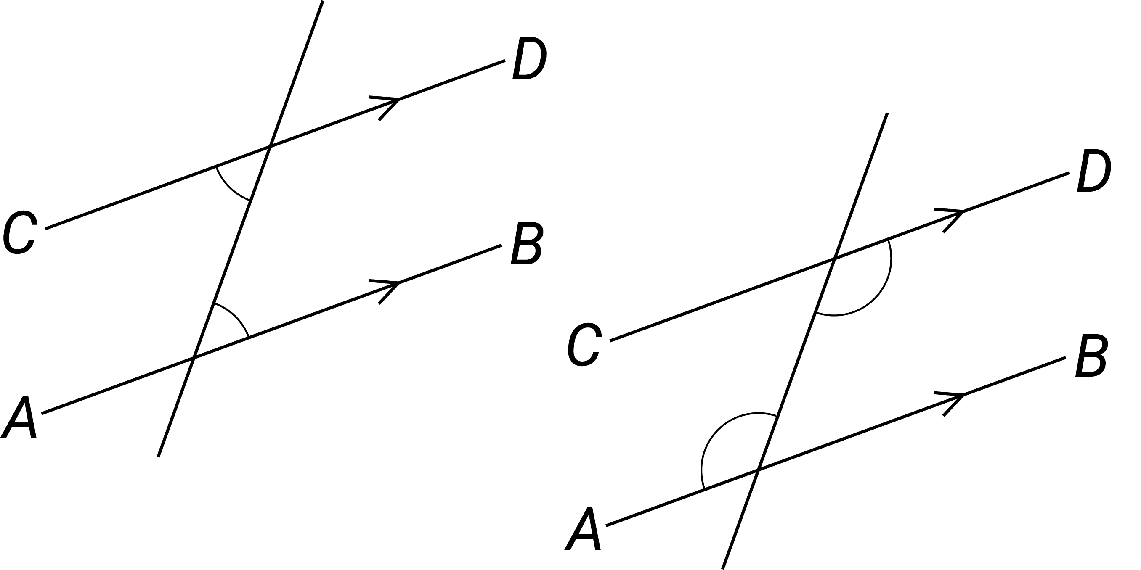
am
Any time before midday when using 12-hour time. An abbreviation of the Latin term ante meridiem.
analog clock
A clock with hours marked from 1 to 12 arranged in a circle and moving hands to show you the time.
angle  The figure formed at the intersection of 2 rays in the plane with a common endpoint, called its vertex. It is typically indicated with an arc. | 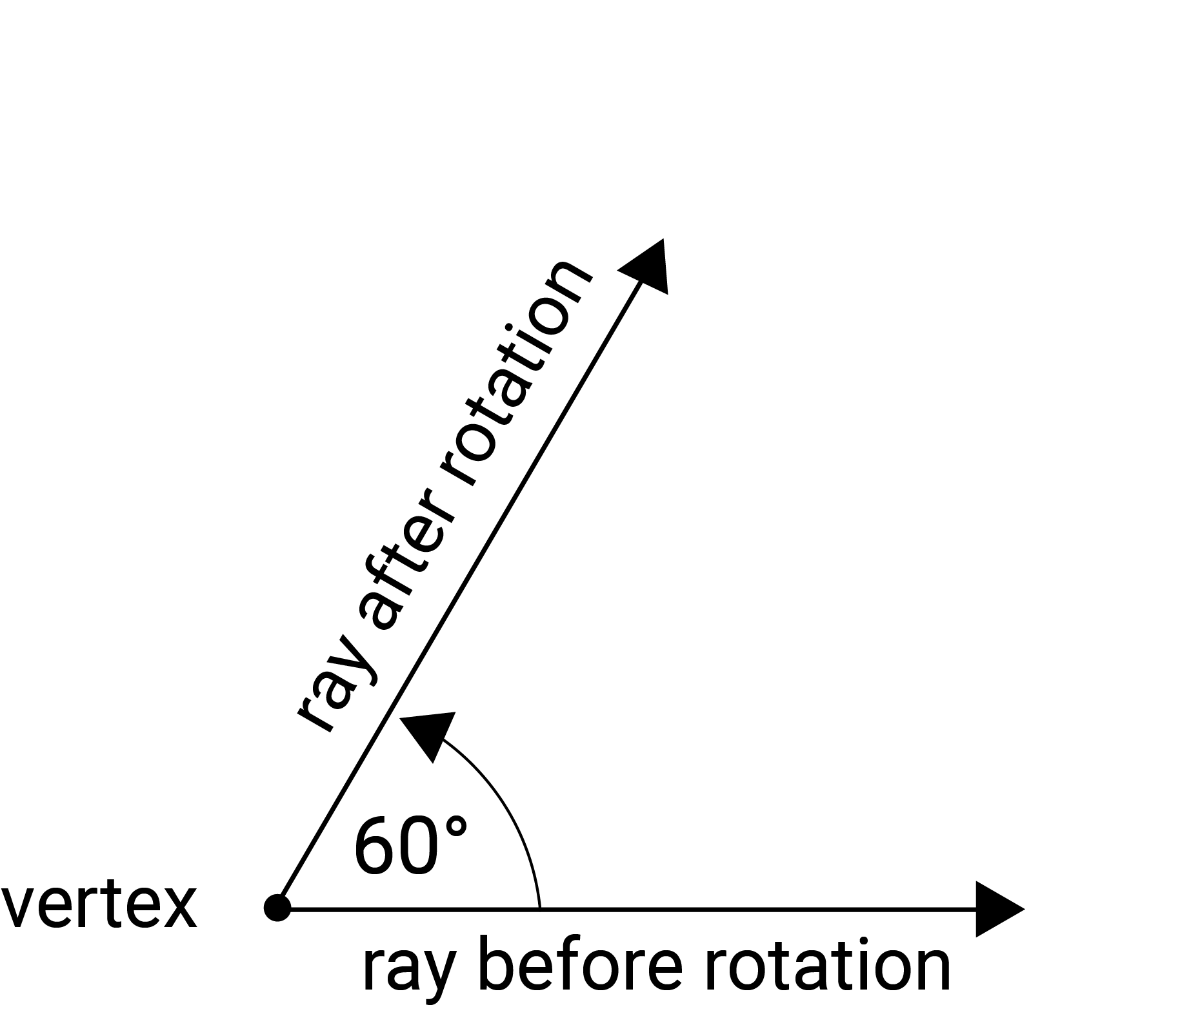
angle of depression  The angle between horizontal and the line of sight from an observer to an object that is lower than the observer. | 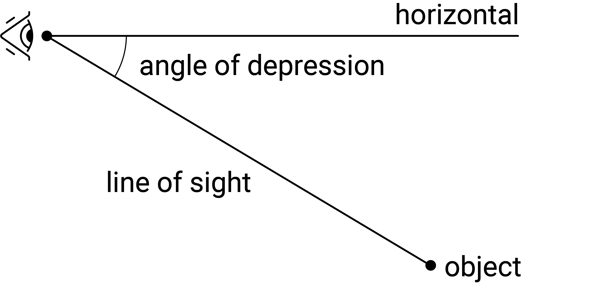
angle of elevation  The angle between horizontal and the line of sight from an observer to an object that is higher than the observer. | 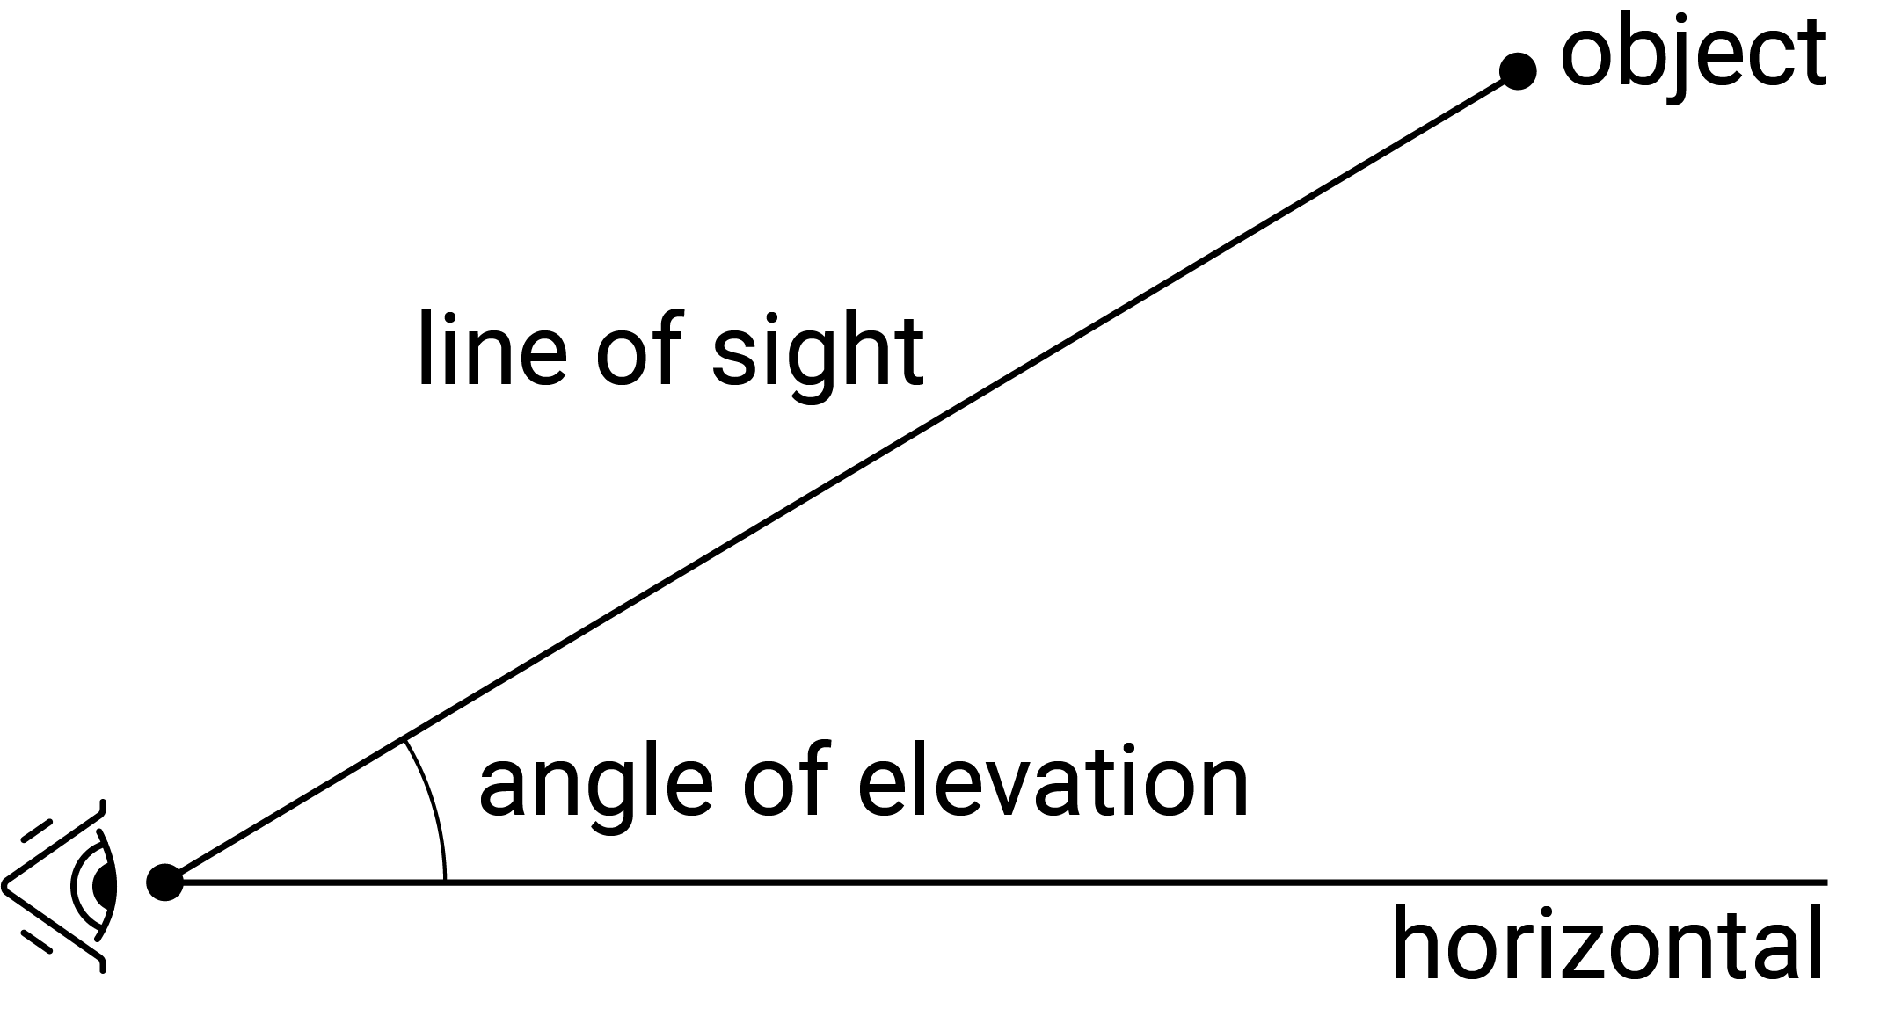
angles at a point  The sum of the angles with vertices at a common point in the plane is equivalent to 4 right angles or 360 degrees. This spatial fact can be applied to determine the size of missing angles. | 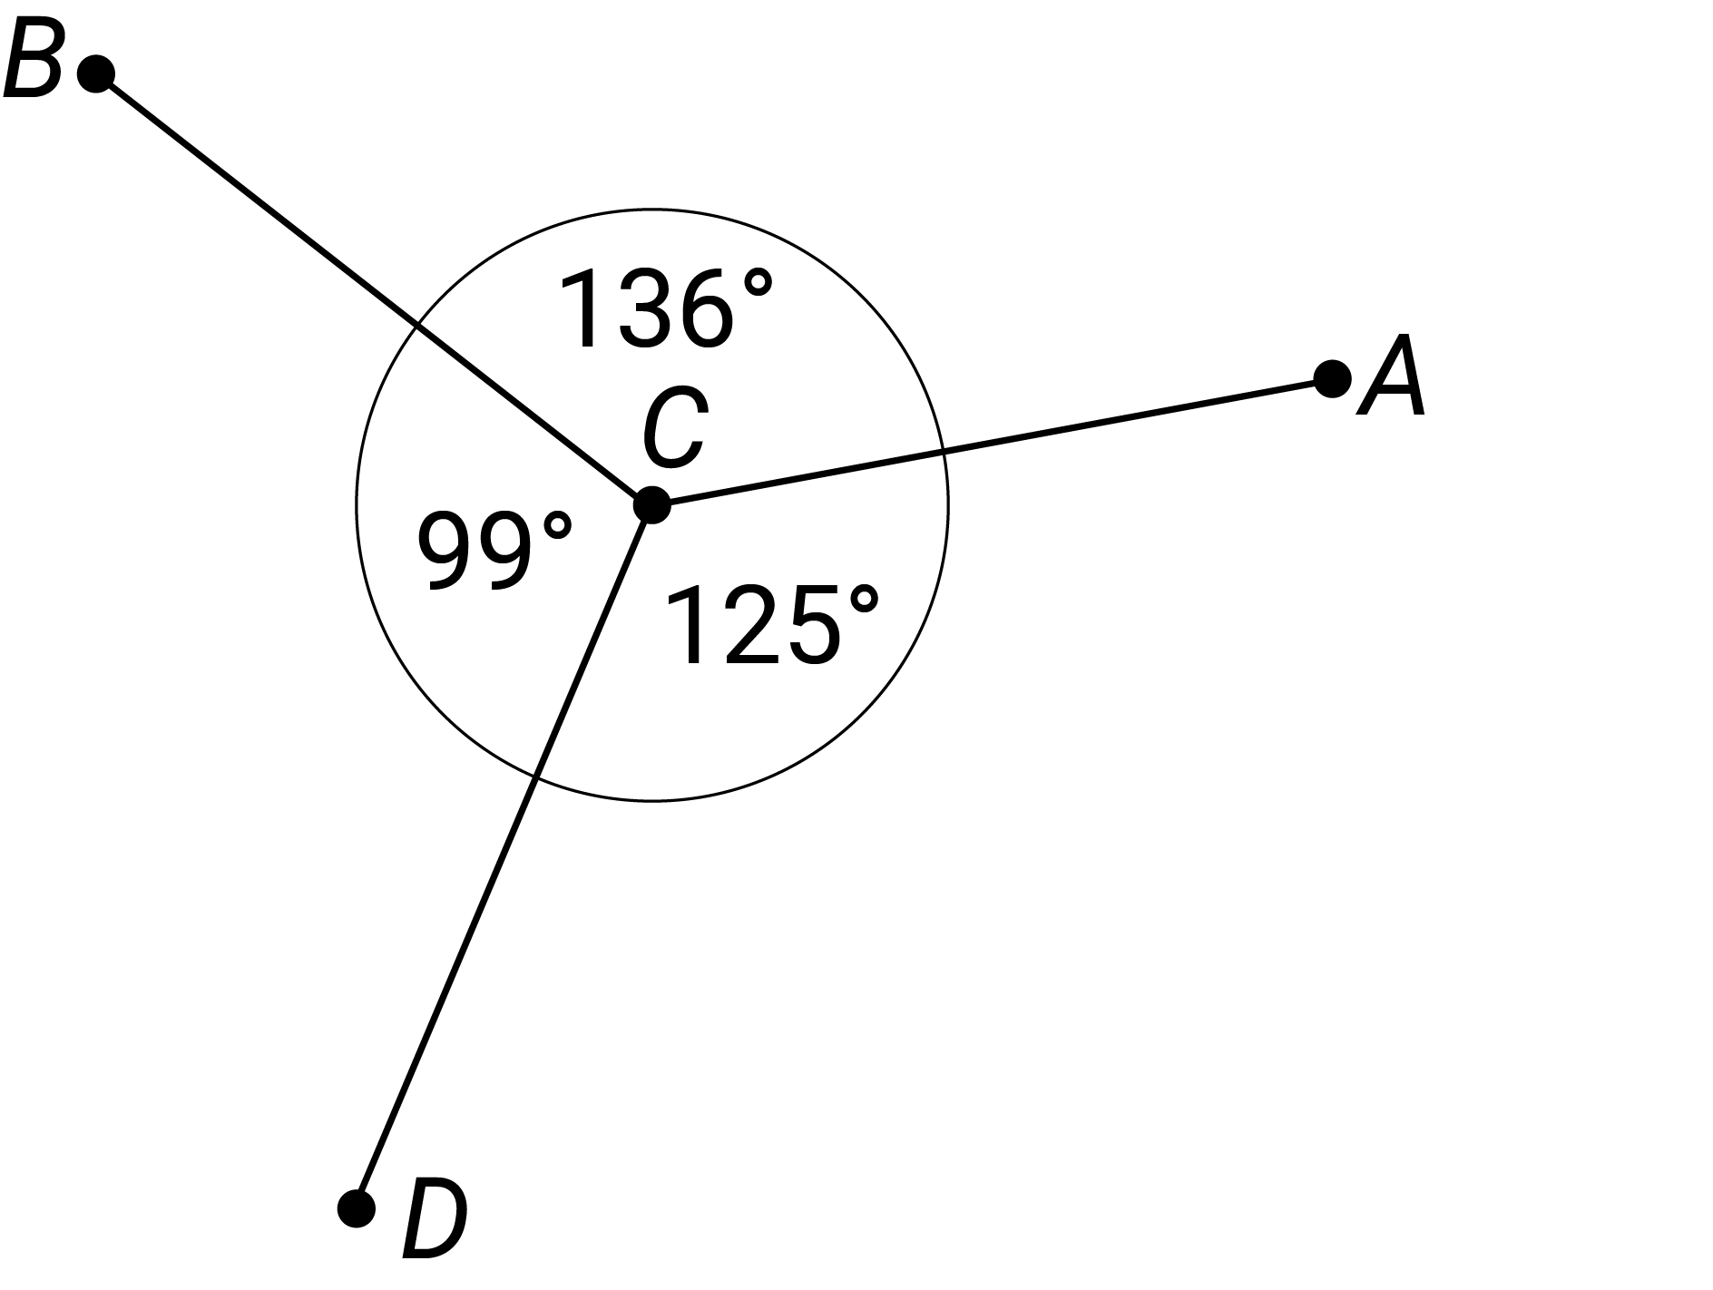
angles on a straight line  The sum of the angles that form a straight line is equivalent to 2 right angles or 180 degrees. This spatial fact can be applied to determine the size of missing angles. | 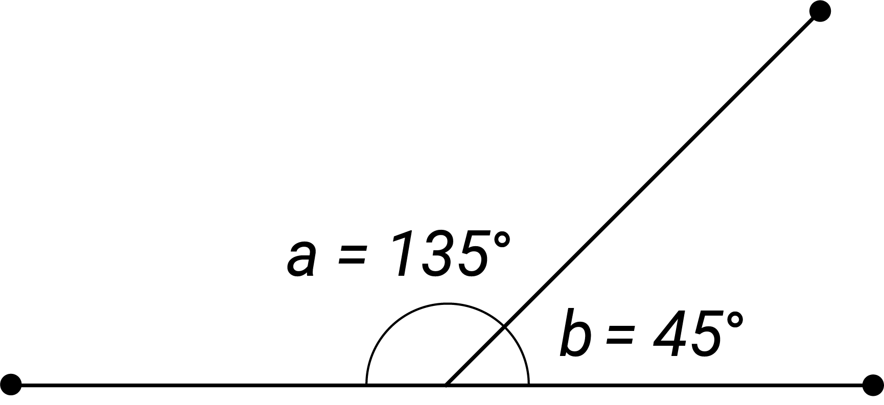
approximate
To obtain or state a value to a particular accuracy.
approximation
A result which is not exact, but is close enough for a given purpose, e.g. giving an approximation of the area of a complex shape by using a combination of basic shapes.
area  The amount of interior space bounded by the perimeter of a shape. It is usually measured in square units. For example, the area of this rectangle is given by $8×2=16$ units. | 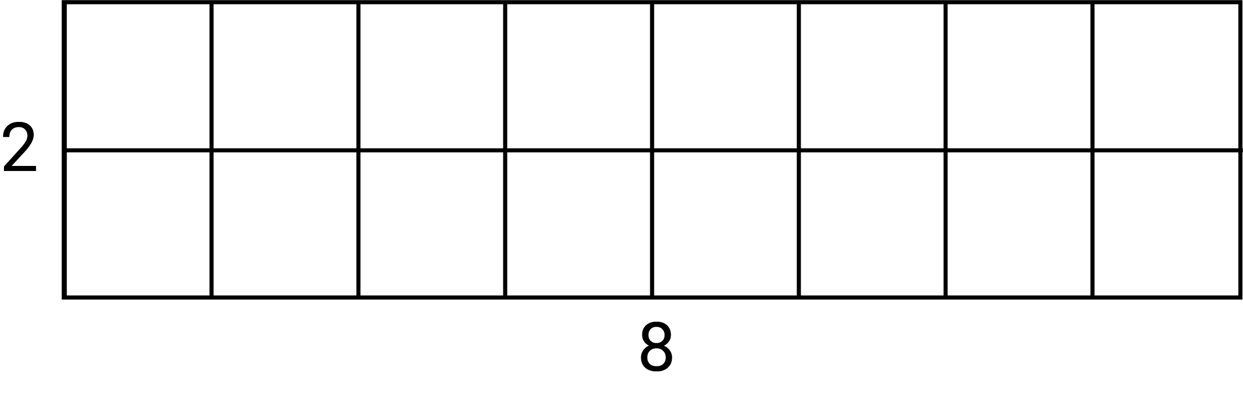
array  An ordered collection of discrete objects or numbers, e.g. rectangular arrangements of rows and columns such as 2 arrays of dots ($4×6$ and $8×3)$ produce 2 different representations of the number $24$. | 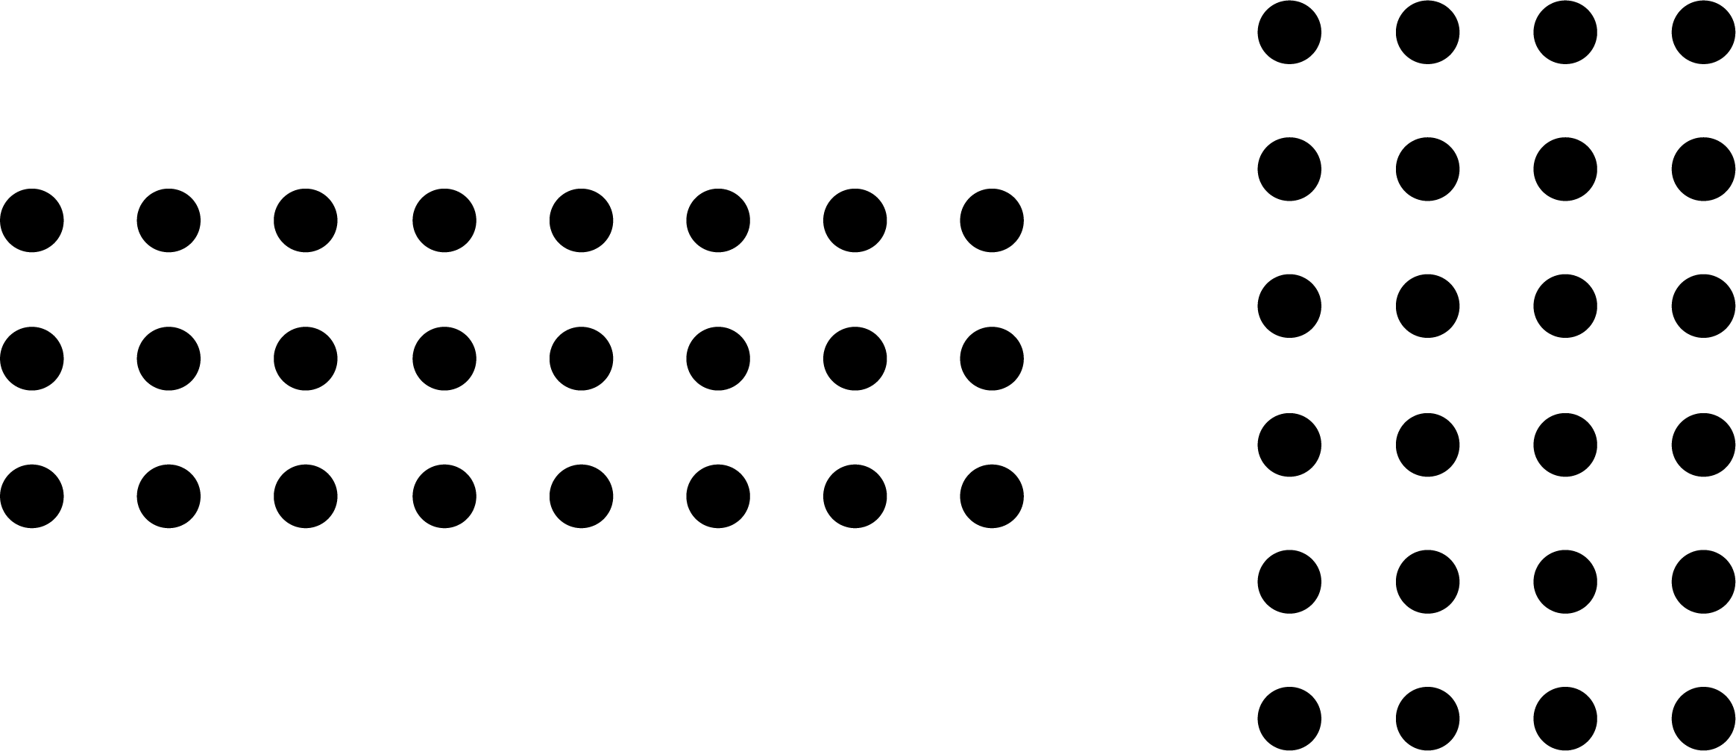
Asia/Asian
Geographically, the largest continent, bounded by Europe and the Pacific, Arctic and Indian oceans. It can be described in cultural, religious, historical and language boundaries or commonalities.
assign probabilities
The process of providing a qualitative or quantitative value for the likelihood or chance of an event occurring. This may involve judgement based on experience, experiment, counting or measurement.
association(s)
Relationships between pairs of variables for different data types, e.g. in terms of strength, form and direction.
associative
Of or relating to an operation that when applied to any 3 elements of an expression is the same regardless of which pair of elements (without changing their order) is combined first.

associative law
In general, the addition or multiplication of a set of real numbers gives the same output no matter how the numbers are grouped, e.g. $a+\left(b+c\right)=\left(a+b\right)+c$and $a×\left(b×c\right)=\left(a×b\right)×c.$
attribute
A property of an object or event that can be measured and/or directly or indirectly compared.
B
back-to-back stem-and-leaf-plot  A method for comparing 2 data distributions by attaching 2 sets of ‘leaves’ to the same ‘stem’. | 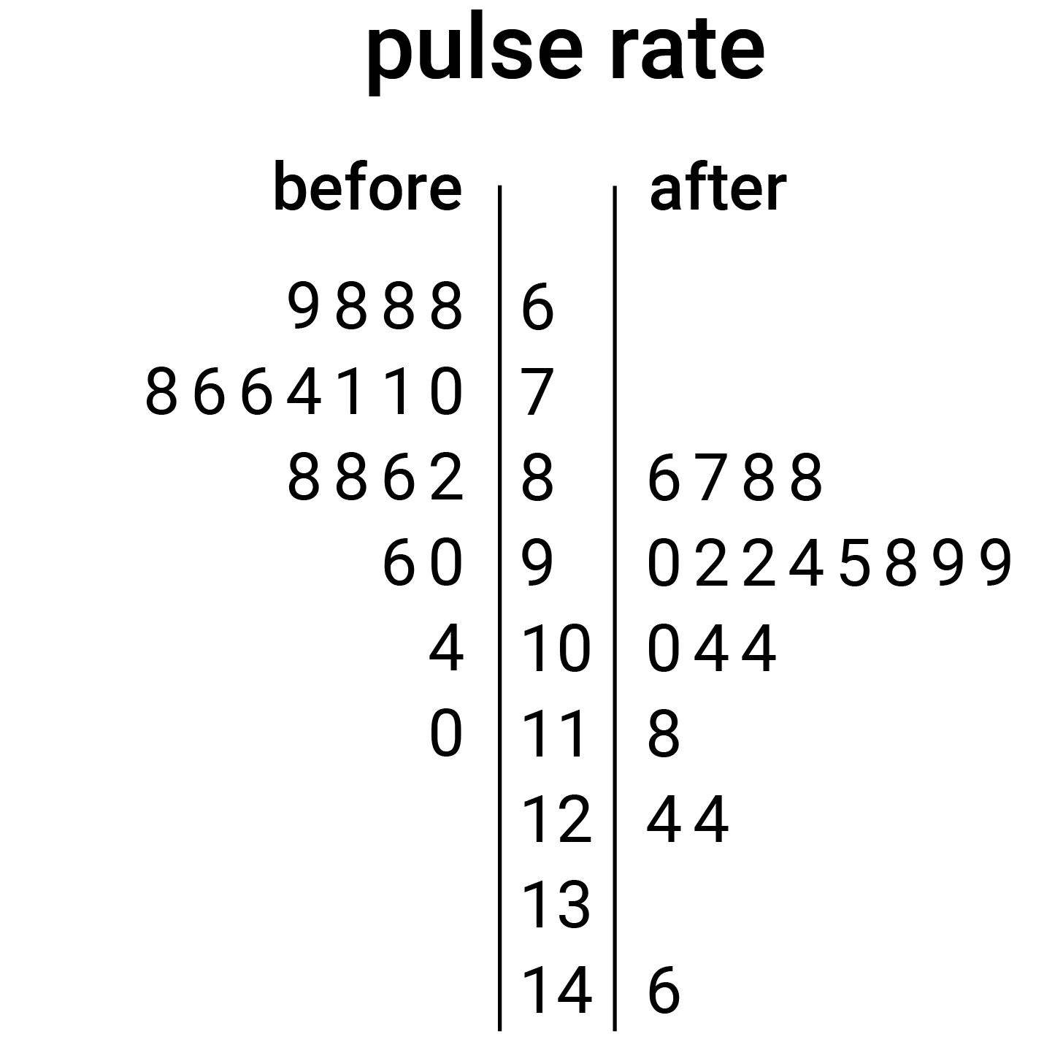
base-10
A number system which uses the digits 0–9 and the value of the digit is determined by its face value and its place value, e.g. $283=2×100+8×10+3×1$ and $283=200+80+3$.
bias (statistics)
A measure being systematically moved away from the true value, leading to overestimating or underestimating that value.
bimodal distribution  The distribution of a set of data that has 2 modes. The term 'bimodal' is also used if the graph of the distribution has 2 distinct peak values, which may not be equal. | 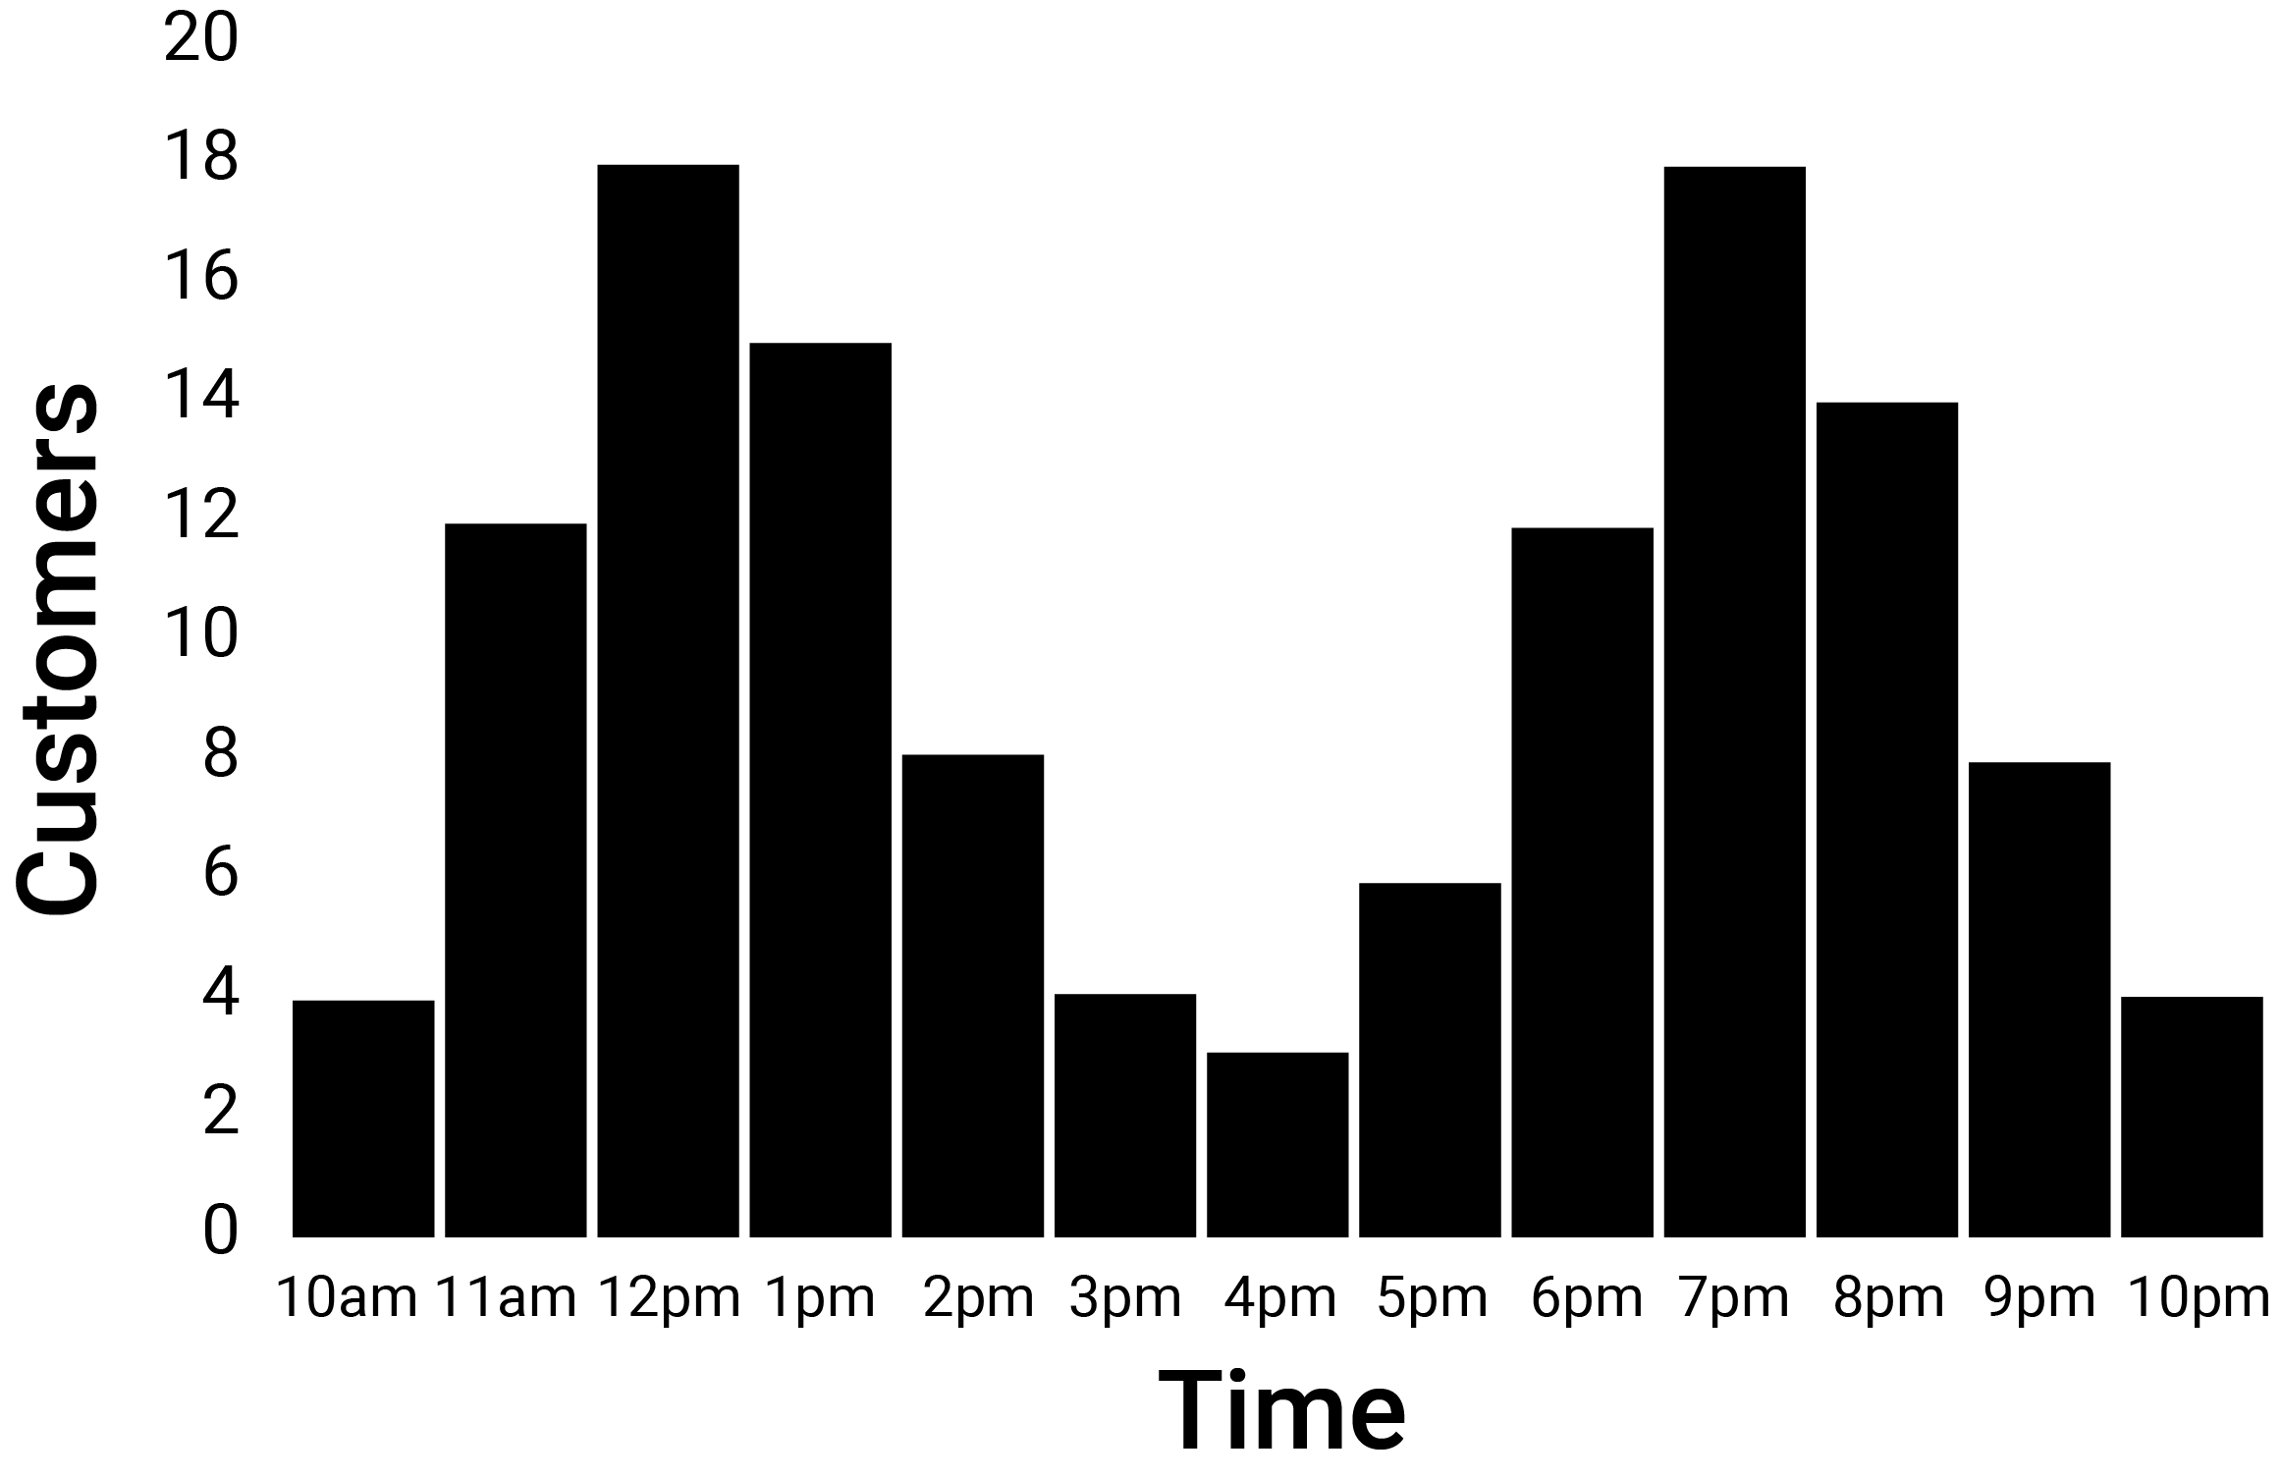
bivariate data
Data relating to measurement of 2 variables. It can be categorical data, numerical data or a combination of both.
boxplot  A graphical display of a 5-number summary of data. The ‘box’ covers the middle 50% of scores. The ‘whiskers’ extend to the maximum and minimum values in the data set. | 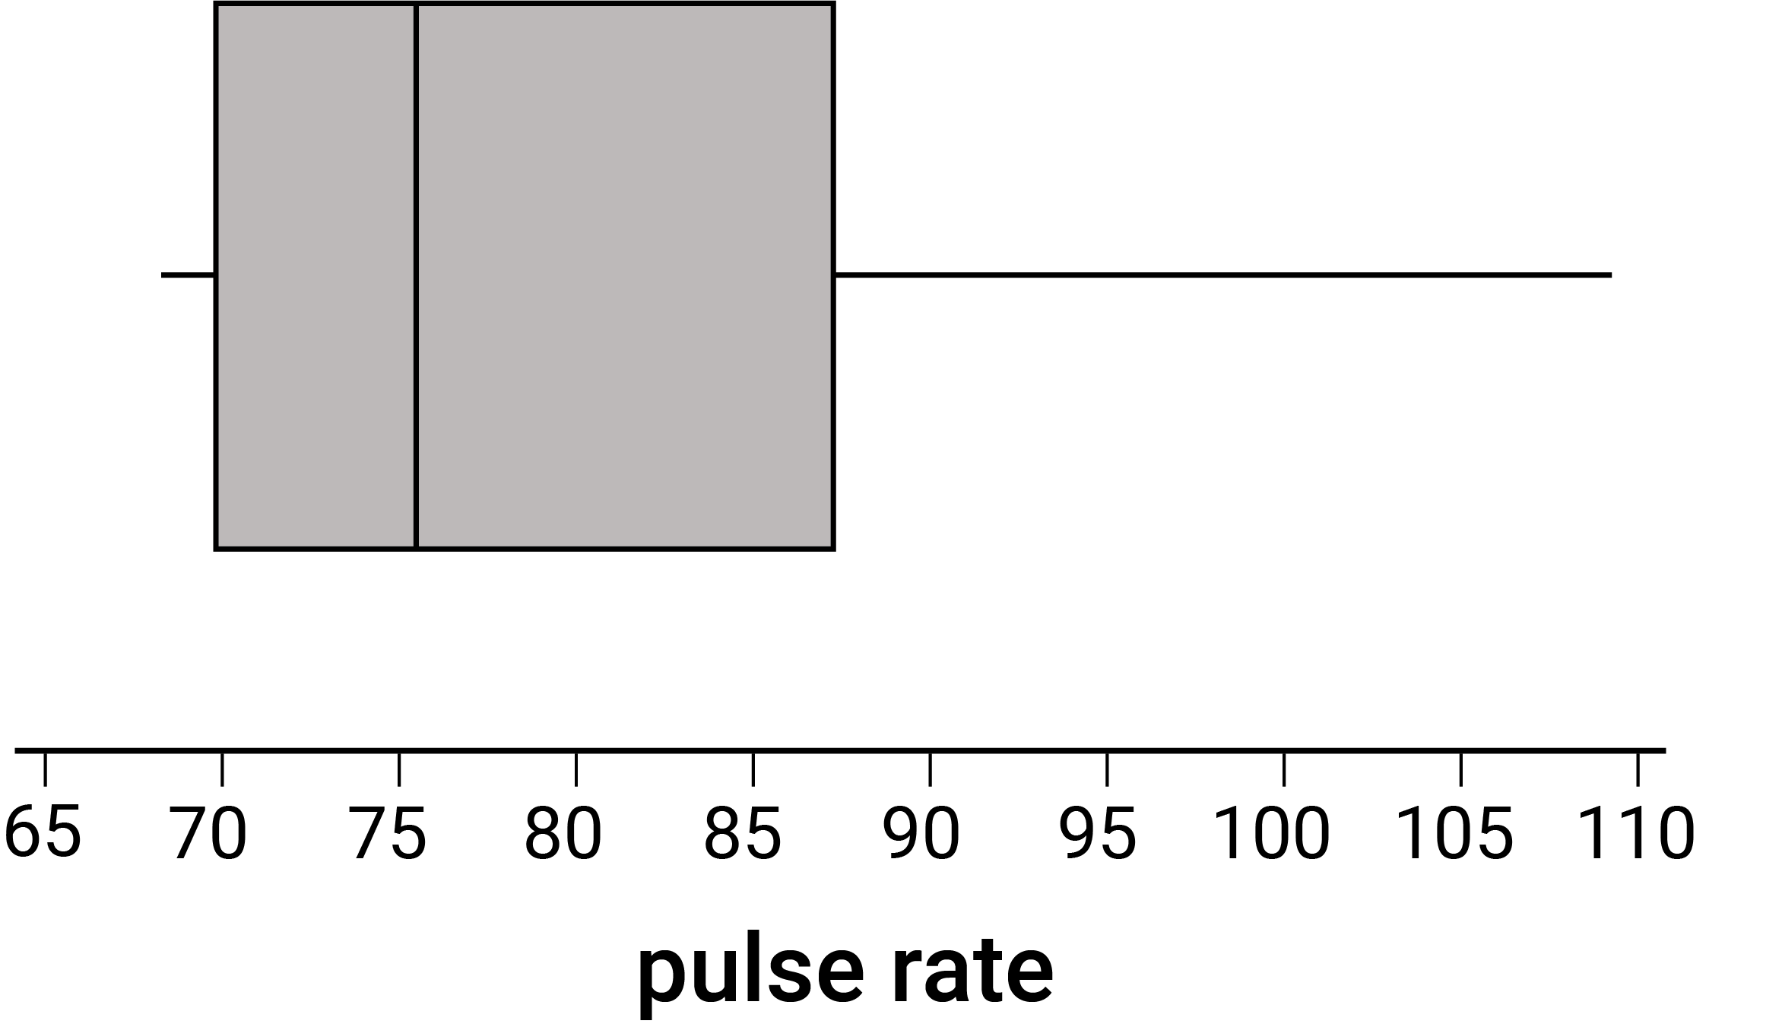
C
capacity
The amount a container will hold. It is often used in relation to the volume of fluids. Units of capacity (volume of fluids or gases) include litres (L) and millilitres (mL).
Cartesian coordinate system  The positioning system for any point in the Cartesian plane, represented by an ordered pair of real numbers (x, y), which are called the coordinates of the point relative to the origin at (0, 0). | 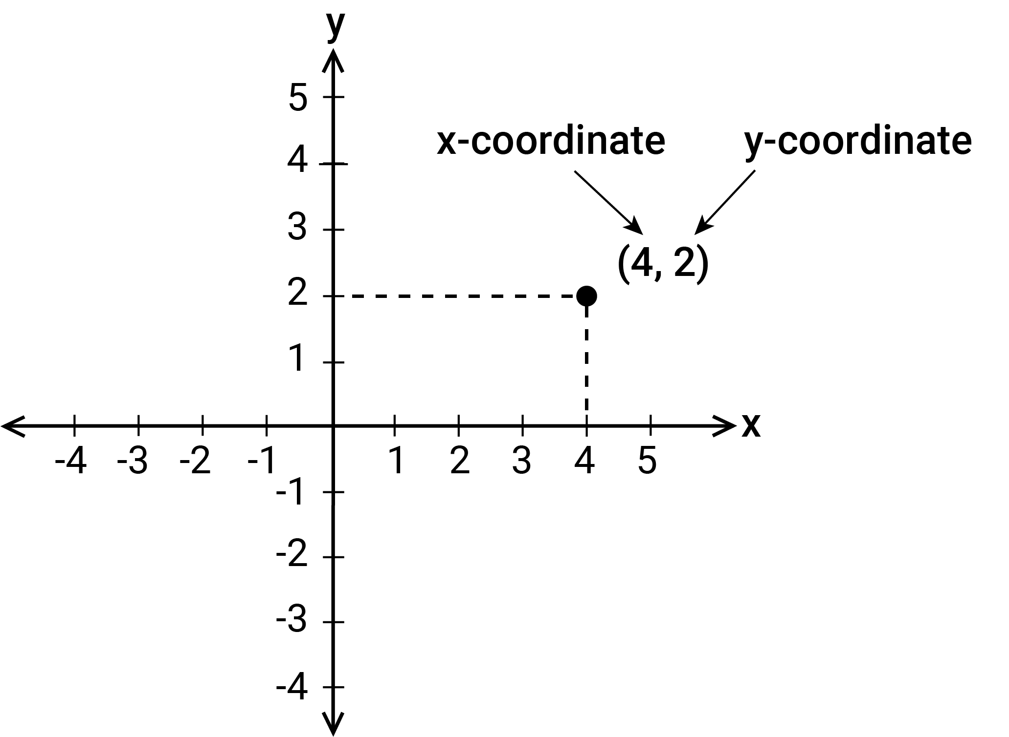
Cartesian plane  A plane divided into 4 regions (quadrants) by 2 perpendicular axes, the x-axis and the y-axis, which intersect at a point called the origin. | 
categorical data
Data in discrete categories, e.g. data on blood groups with values of type A, B, AB or O.
categorical variable
A variable which takes values from sets of categories. There are 2 types of categorical variables: nominal and ordinal.
census
Collection of information about the whole population.
centre (Space)
The middle point of a shape, object or space.
centre (Statistics)
In a set of data, a single value which is used to represent or typify that data. Informally, it is a notion of average.
chance experiment (trial)
An investigation process that involves planning and conducting a repeatable experiment involving chance where more than one possible outcome may occur. Experiments can be single or multi-step and results can vary across trials.
circle  The set of all points in the plane that are a fixed distance (the radius) from a given point (the centre of the circle). | 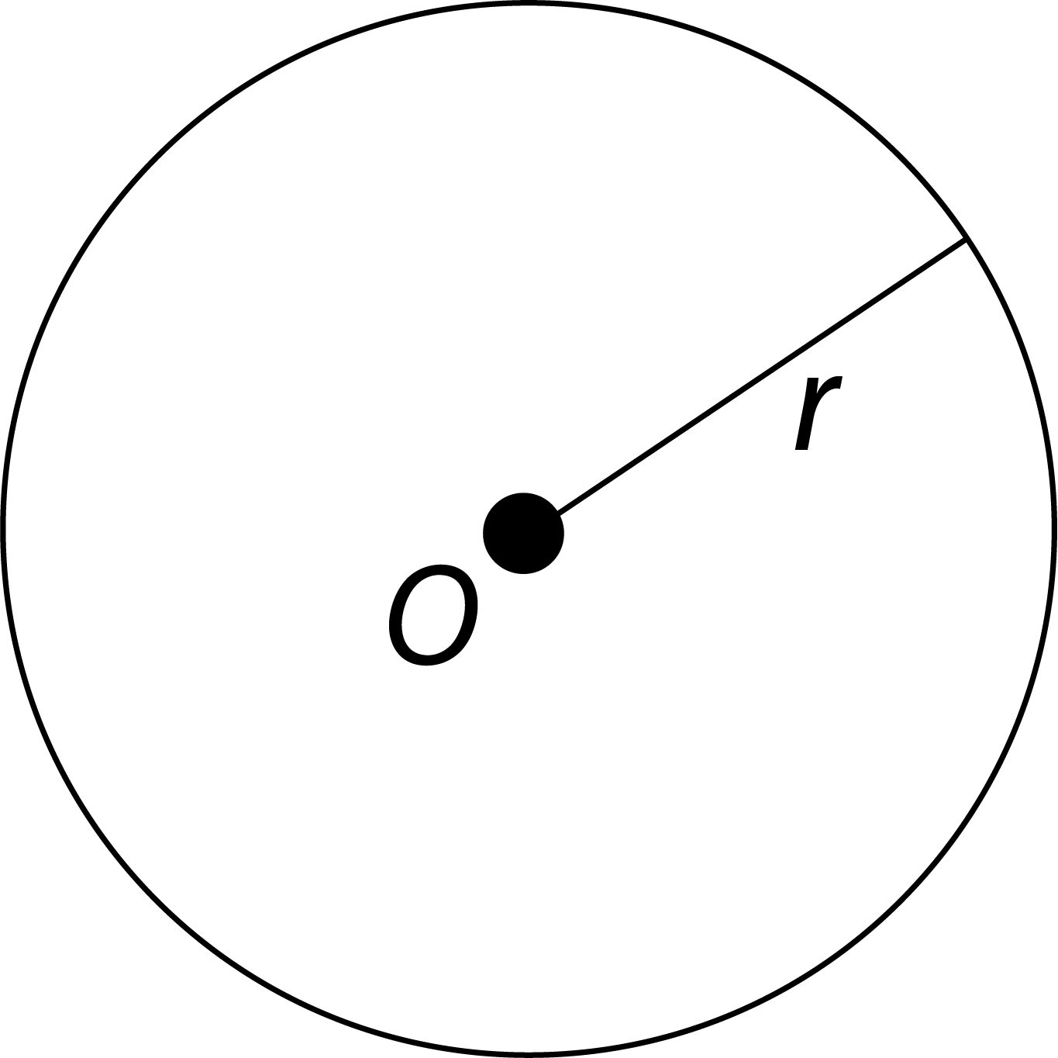
circumference
The boundary (perimeter) of a circle. The length of the circumference $C$ is given by $C=πd$, where $d$ is the diameter. Alternatively, it is given by $C=2πr,$ where$r$ is the radius.
co-interior angles  A pair of angles that lie between a pair of parallel lines cut by a transversal and have a sum of 180 degrees or 2 right angles. | 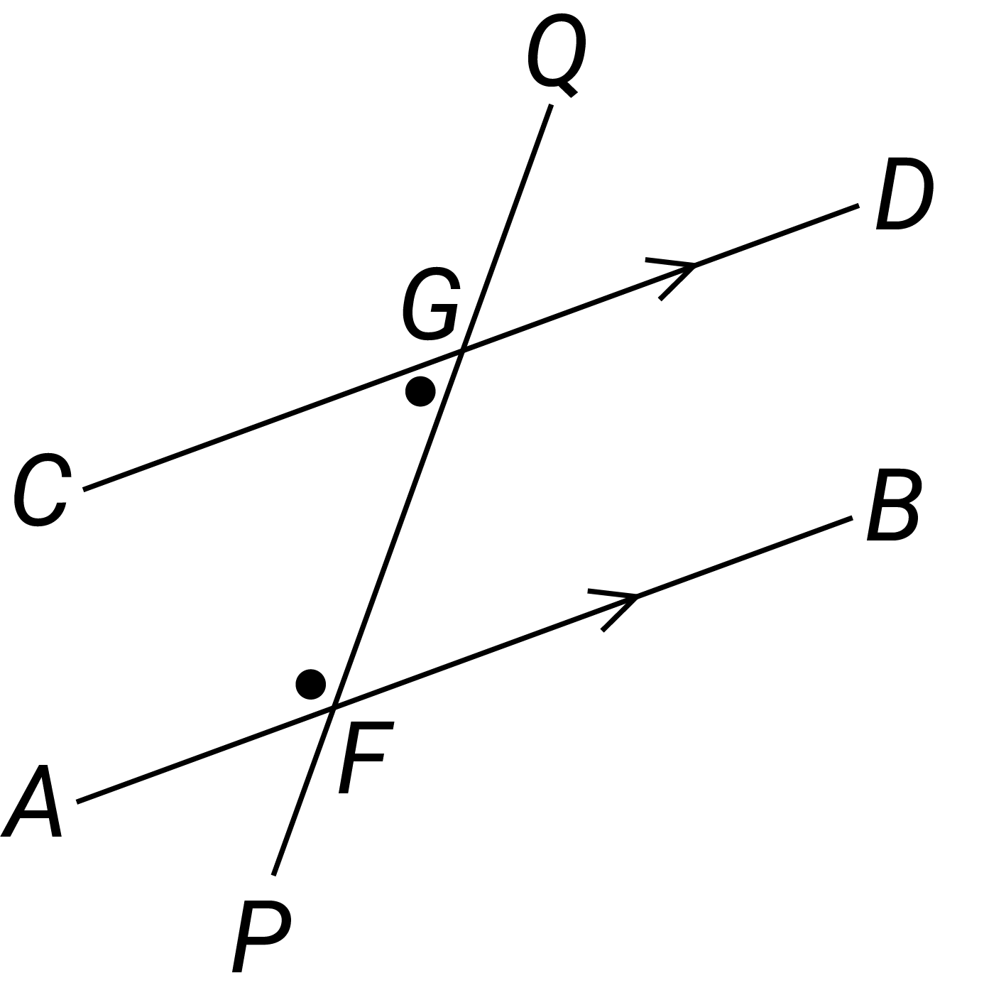
colonisation
The act of setting up a colony away from one’s place of origin. With humans, it can be seen negatively because it tends to involve an invading culture taking control over an indigenous population.
column graph  A graph for organising and displaying categorical data. Equal-width rectangular bars are constructed for each category with height equal to the observed frequency of the category. | 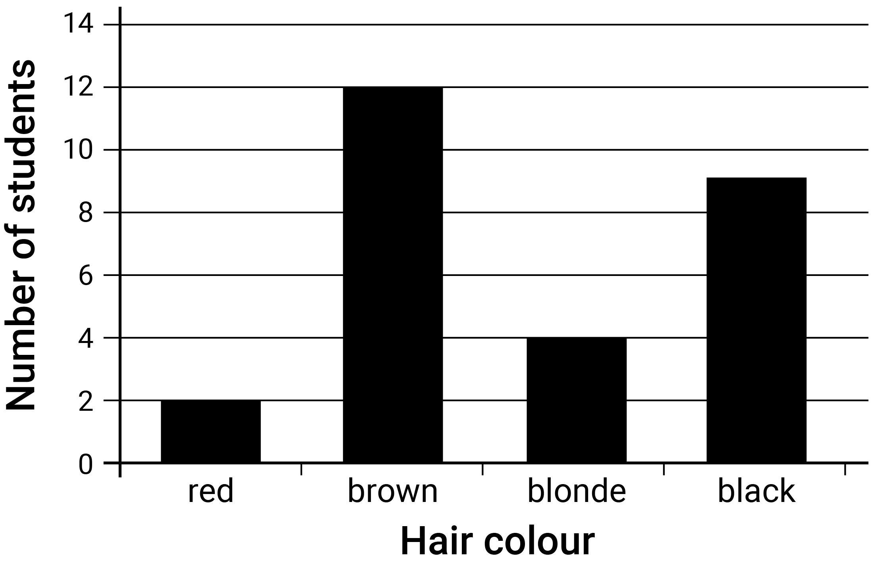
commutative
An operation in which the result of applying it to any 2 elements of a set is the same, regardless of the order of the elements. Addition and multiplication are commutative on the set of natural numbers.
commutative property
In general, the commutative property of addition and multiplication of real numbers is that for all real numbers $a$ and $b$, $a + b = b + a$ and $a × b = b × a$ respectively.
complementary angles  Two adjacent angles that form a right angle, i.e. the sum of the angles measured in degrees is $90°$. | 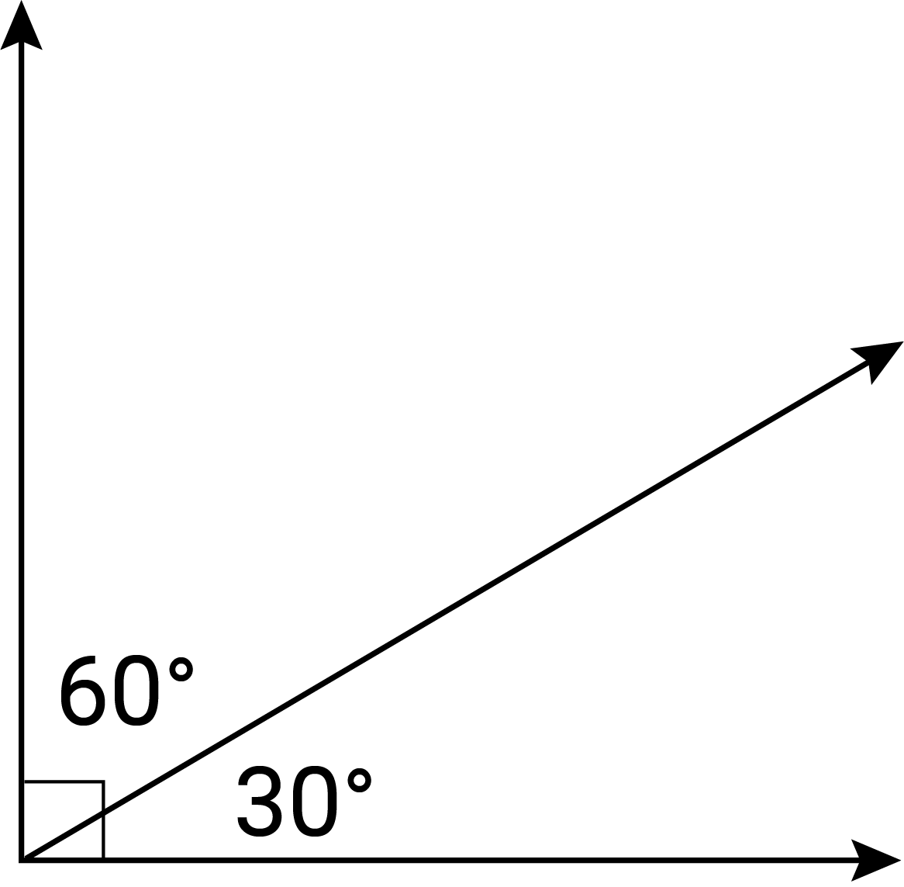
complementary events
Two mutually exclusive outcomes in a probability experiment, such that Pr$(A)$ + Pr$(B)$ $= 1$ where Pr$(A)$ is the probability of event $A$ and Pr$(B)$ the probability of event $B$.
complex shapes and objects  A complex shape is a closed shape comprised of a number of plane shapes. Complex objects are comprised of simpler objects. | 
composite number
A non-zero natural number that has a factor other than 1 and itself.
composite shape  A shape that is formed by combining other plane shapes. Composite shapes are often described as 'complex' when they are made up of many and different shapes. | 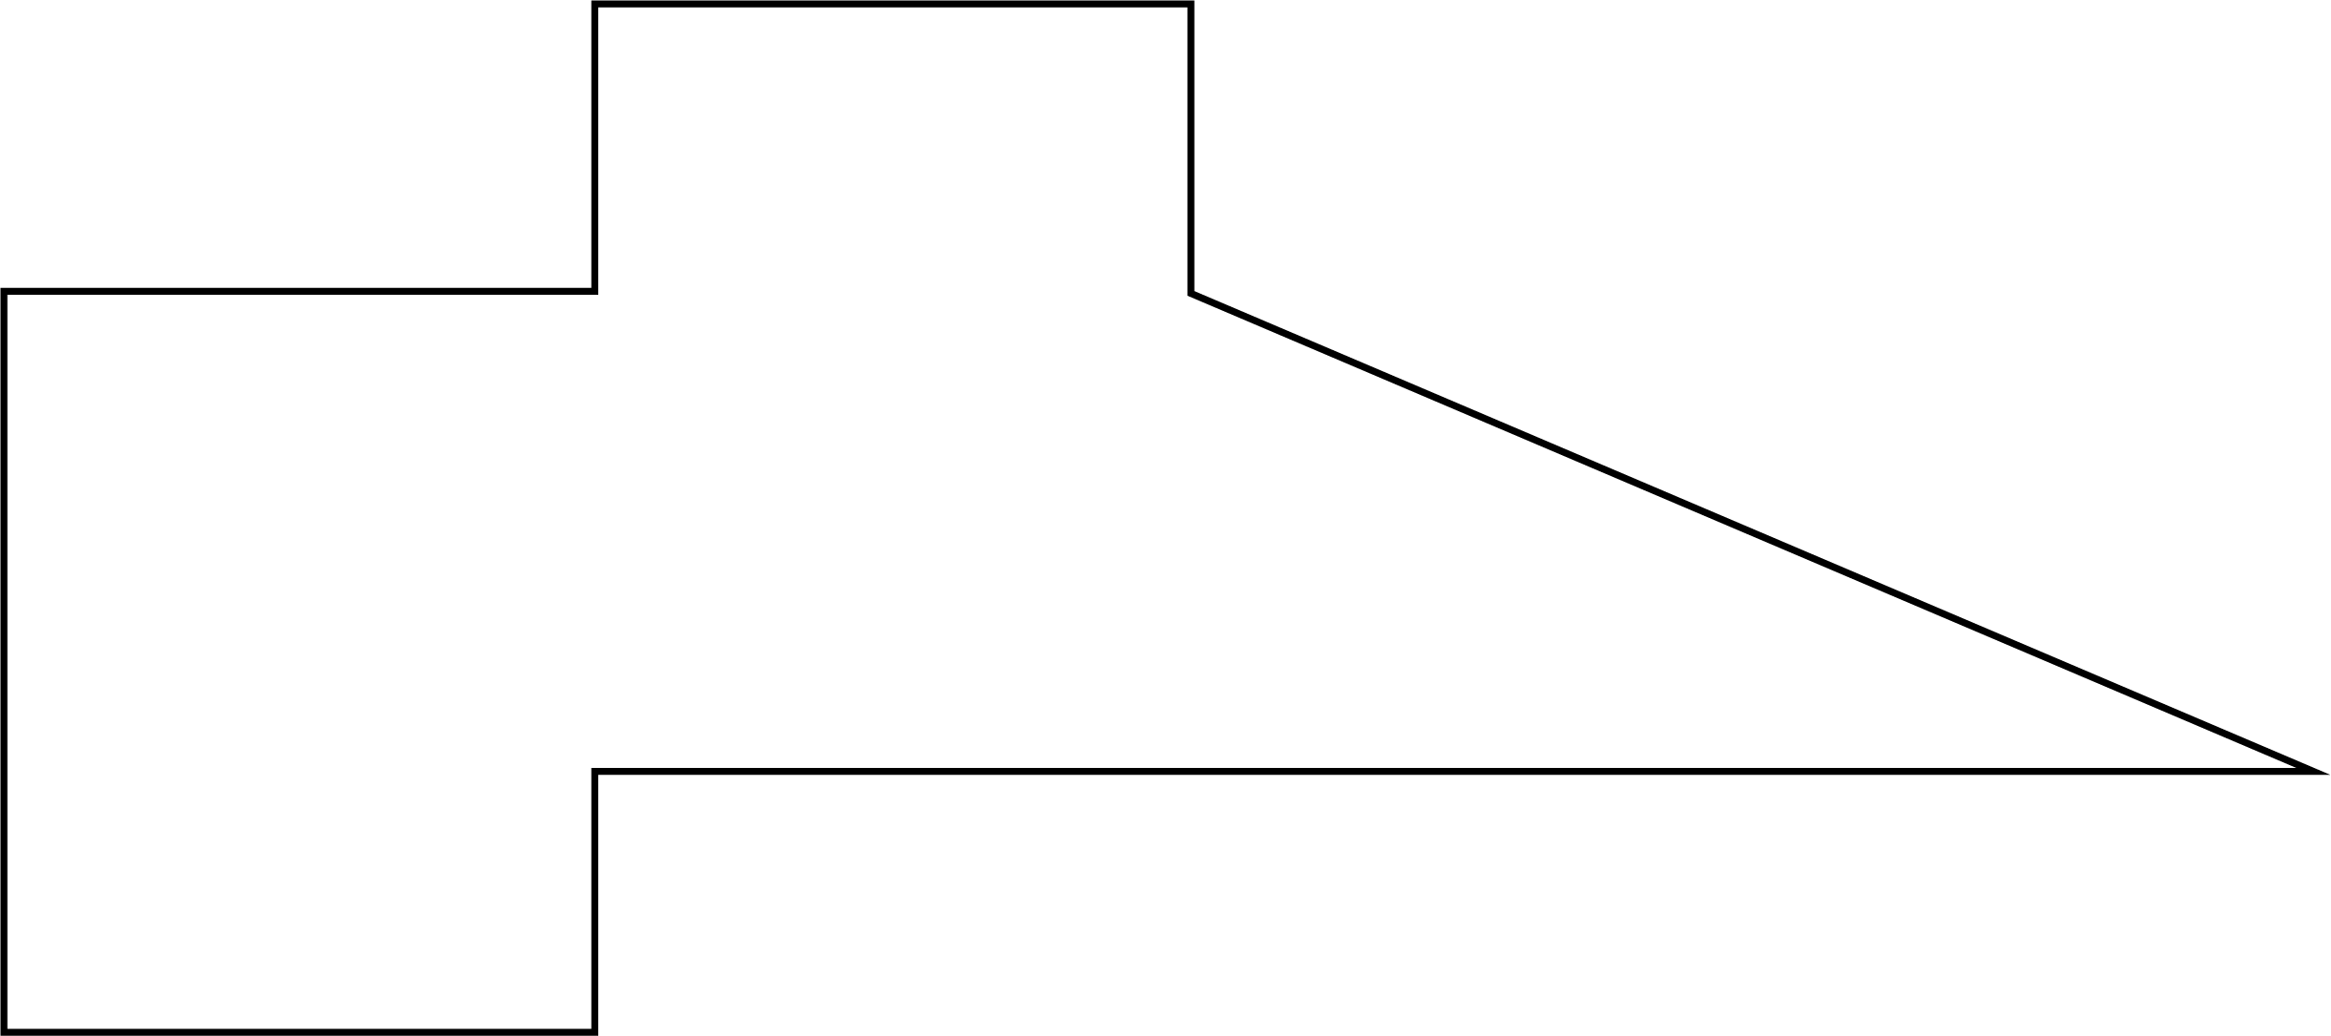
compound event
In probability, an event that consists of more than one event occurring at the same time, e.g. tossing a coin and selecting a card.
compound interest
The interest earned by investing a sum of money (the principal) when each successive interest payment is added to the principal for calculating the next interest payment.
compounding error
The increasing level of error that arises when measurements with errors are used to calculate other quantities.
computation
The action of performing a mathematical calculation. It can be performed mentally or by using an algorithm or a digital tool, such as a calculator.
computational thinking
A way of thinking which helps to organise data logically by breaking down problems into parts; defining abstract concepts; and designing and using algorithms, patterns and models.
conditional probability
Consideration of whether the knowledge of the occurrence of one event, A, affects the probability of occurrence of another event, B.
cone  An object that is formed by taking a circular base and a point not in the plane of this circle called the vertex, and joining the vertex to each point on the circumference of the base. | 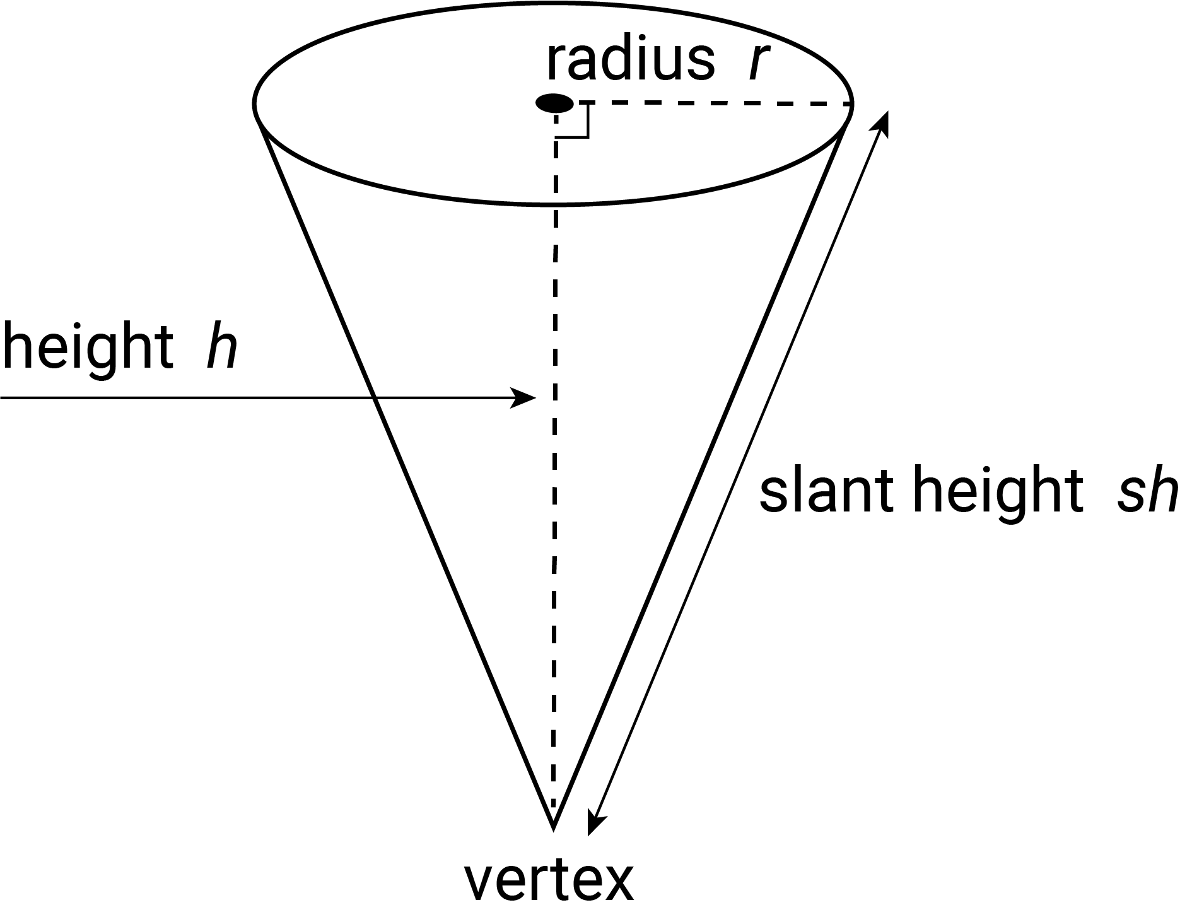
congruent  An exact match between every part of one figure with the corresponding part of the other figure, i.e. congruent figures can be exactly superimposed on each other. | 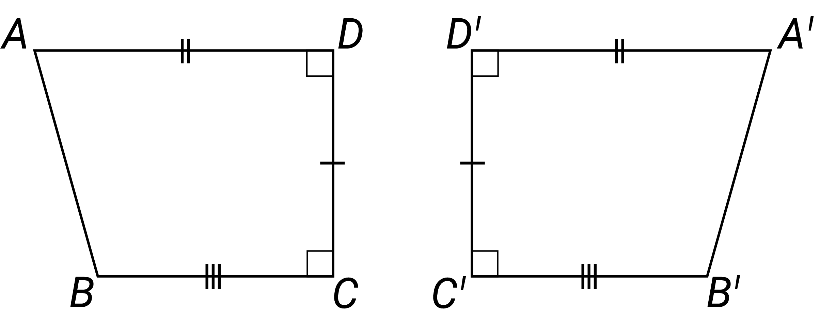
congruent triangles  Triangles that have the same size and shape. When not all measures are known, the determination can be made using the 4 standard congruence tests for triangles (SSS, SAS, AAS, RHS). | 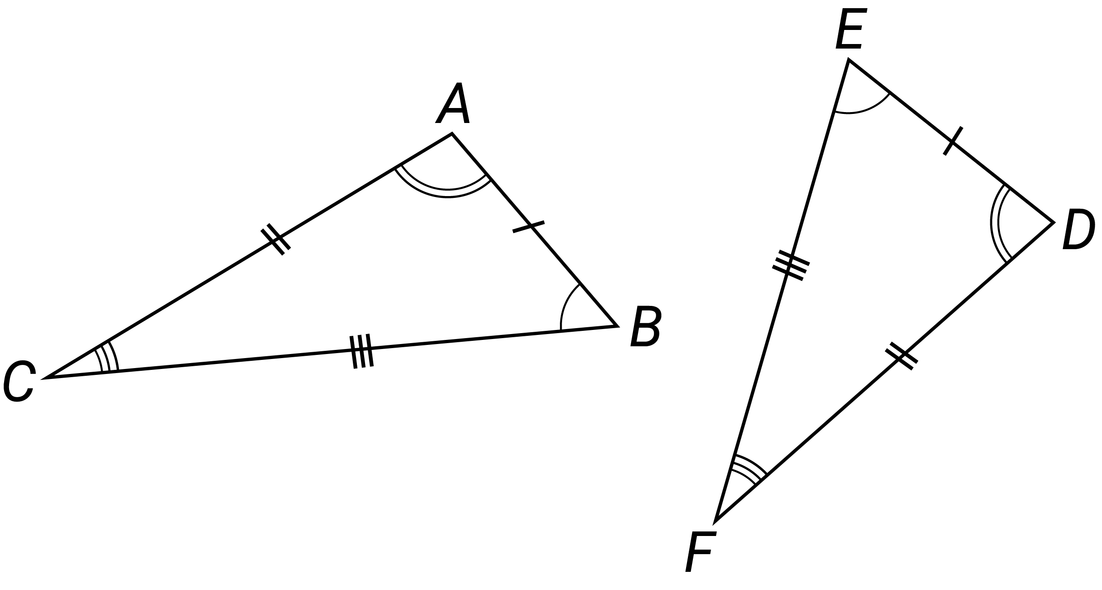
conjecture
A statement whose truth or otherwise is not yet determined but is open to further investigation, e.g. Goldbach's conjecture of 1742 has not yet been either proven to be true or shown to be false.
construct
To draw, make or build a mathematical object such as a shape, pattern, algorithm or proof.
context
The situation or setting of an event, problem or application. Contexts can be real world or constructed.
continuous numerical variable
A numerical variable that can take any value that lies within an interval. In practice, the values taken are recorded to the accuracy of measurement of the instrument used to obtain these values.
coordinate system
A system for showing a set of values that give an exact position, e.g. Cartesian coordinate system, grid map or a seating plan for a venue.
coordinates
A set of values that define the position of a point or an object in a space. The coordinate system being used will govern the nature of the coordinates.
corresponding angles  Angles that lie in the same relative position at the points of intersection where a pair of parallel lines is cut by a transversal and which are equal. | 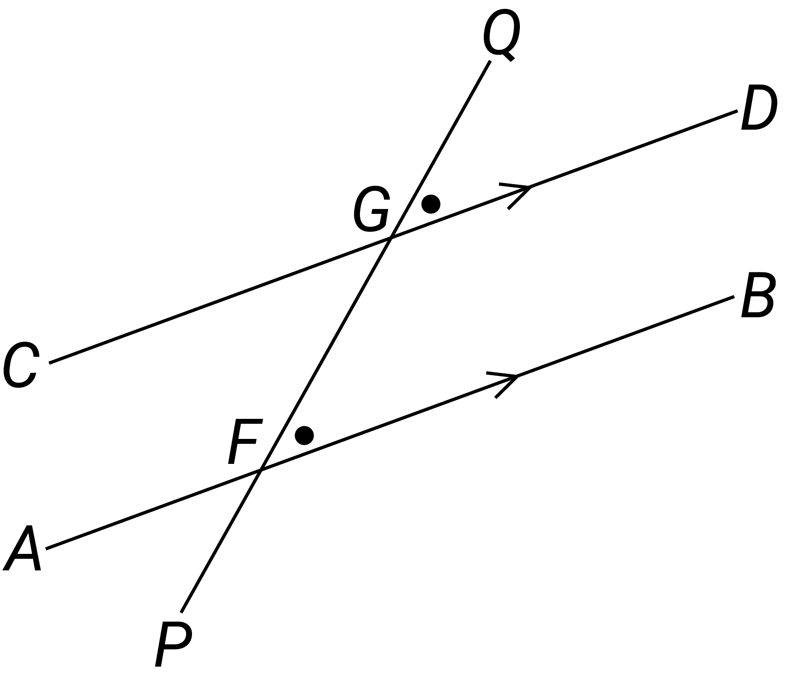
cosine ratio  The ratio of the length of the base, $b$, of a right-angled triangle to the length of its hypotenuse, $h$, for a given base angle theta, $θ$. In any right-angled triangle, $\cos{θ= \frac{adjacent}{hypotenuse}}$ , where $0<θ<90°$. | 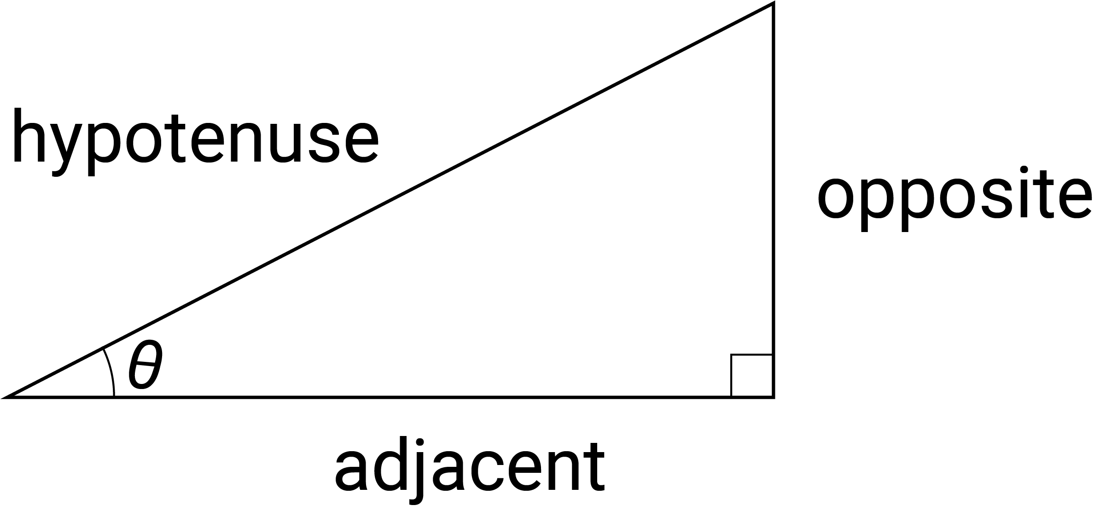
counting
The process of quantifying the number of objects in a set or collection.
Country
A space mapped out that individuals or groups of First Peoples of Australia occupy and regard as their own and having varying degrees of spirituality. It includes lands, waters and sky.
Country/Place
Spaces mapped out that individuals or groups of First Nations Peoples of Australia occupy and regard as their own and having varying degrees of spirituality. They include lands, waters and sky.
cross-section  The intersection of a solid object with a plane. It may differ for a given solid depending on the orientation of the slicing plane. | 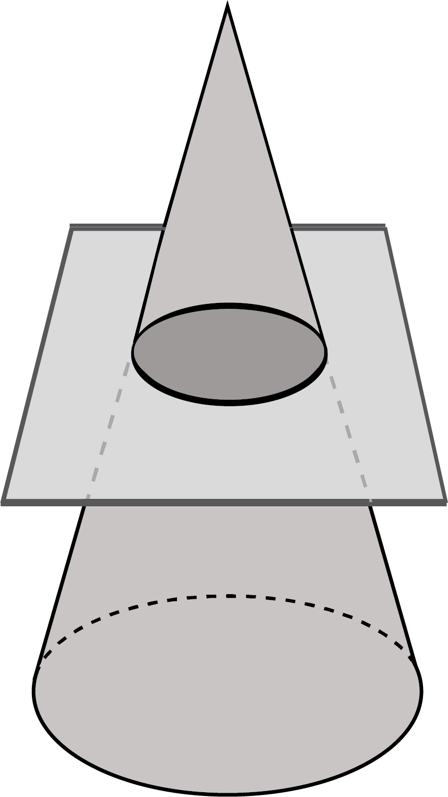
cylinder  An object that has parallel circular discs of equal radius at the ends that are joined by a curved surface. | 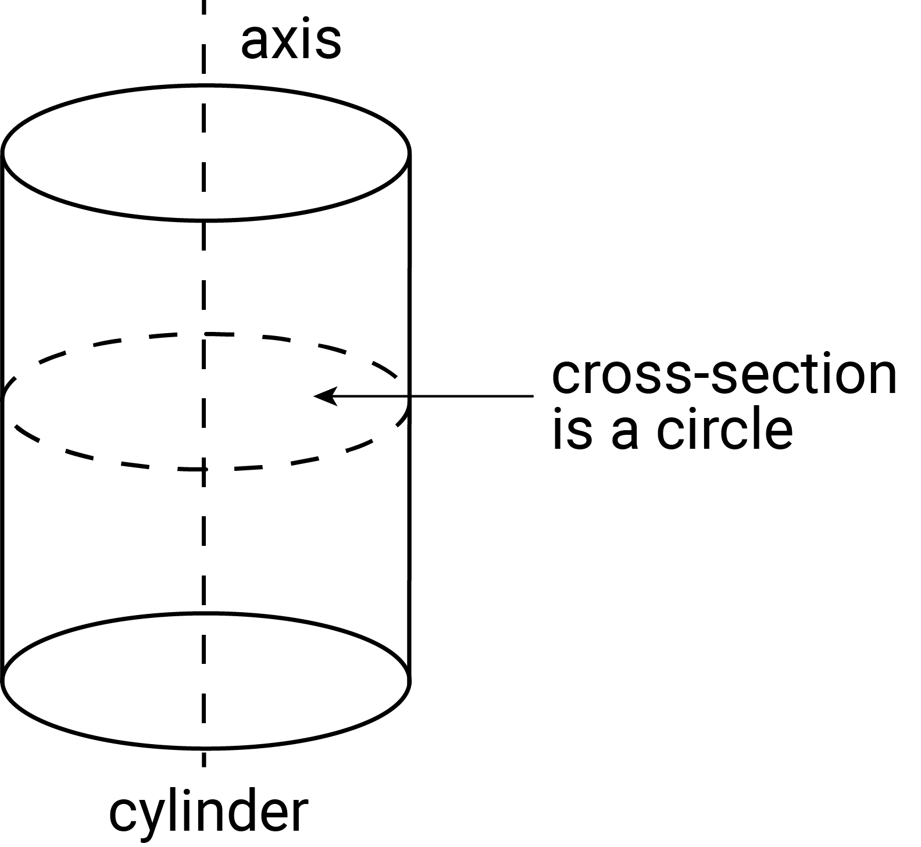
D
data
A general term for a set of observations or measurements collected during an investigation. Primary data is collected by the user; secondary data is collected by others.
data displays
Visual formats for organising, representing and summarising data. Also called visualisations.
data distributions
Patterns in the values of a set of data. The representation used to show the distribution depends on the type of data and how it is measured.
decay
Decrease in the value of the dependent variable of a function as the value of the independent variable increases.
decimal
Used to describe aspects of the base-10 number system. The decimal point (. or ,) separates the whole number part of a number from its decimal part.
degrees
A unit of measurement for measuring an angle. Angles are measured as a proportion of a full turn which is equivalent to $360$ degrees, so that one degree is equal to $\frac{1}{360}$ of a full turn. Written as $α$°.
denominator
In the fraction $\frac{a}{b}$, $b$ is the denominator. It is the number of equal parts into which the whole is divided.
diagonal
A line segment joining 2 vertices of a polygon that do not share an edge.
diameter  A chord passing through the centre of a circle. The word is also used for the length of the diameter. | 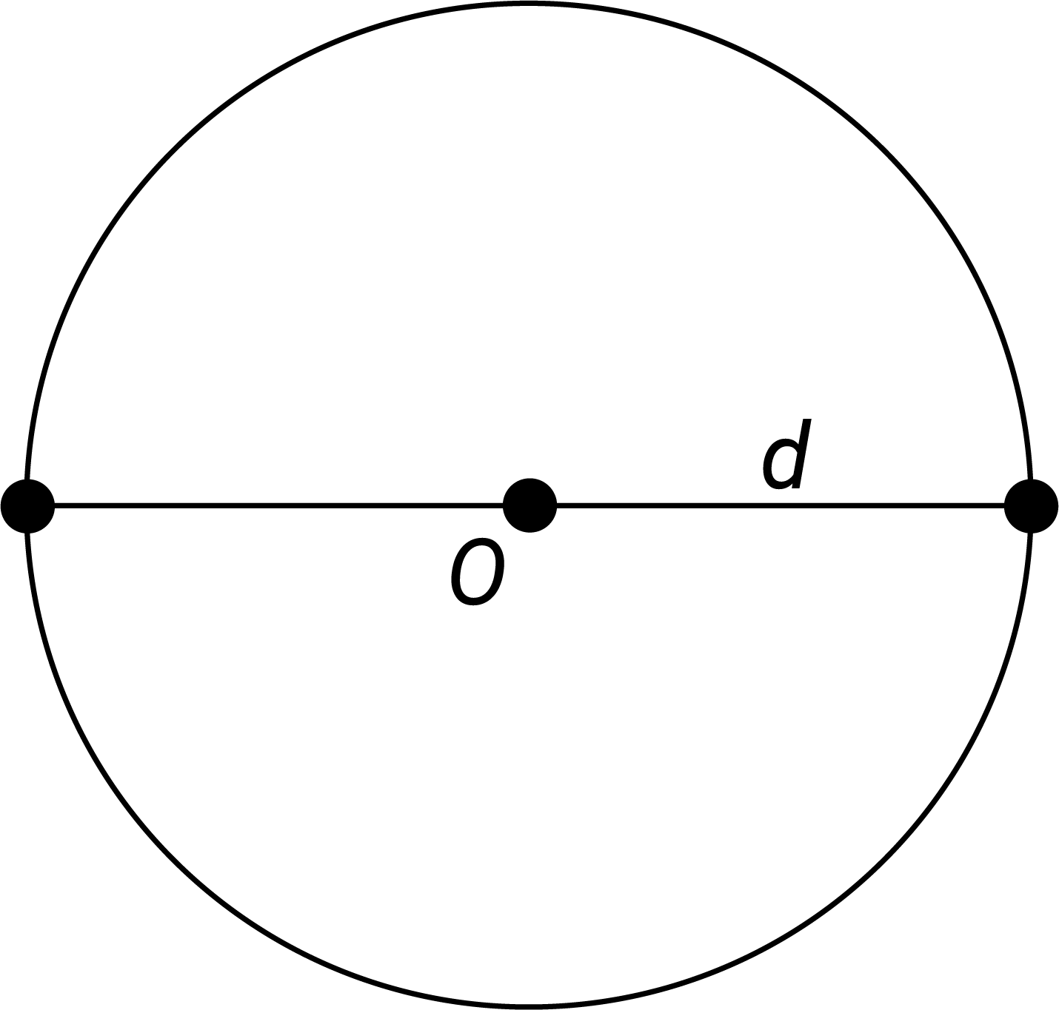
digit
A single symbol that is used to represent a number as a numeral. In the base-10 number system there are 10 digits: 0, 1, 2, 3, 4, 5, 6, 7, 8 and 9.
digital tools
Electronic devices, programs, websites or online resources that can be used to support the learning and doing of mathematics.
direct comparison
Comparing objects and events using a particular attribute, e.g. measuring the length of 2 pencils by placing them side by side or starting 2 events at the same time to compare duration.
direct proportion
The relationship between corresponding values of 2 variables in a fixed ratio relative to each other; i.e. for variables $x$ and $y$, $\frac{y}{x}=k$; and $y=kx$, where $k ≠ 0$.
directional language
Words that communicate position, location and movement within a space.
discrete numerical data
Numerical data that can take only a countable number of values, e.g. the number of people in a car, or clothing sizes.
distributive
An operation that can take priority over the operation used for combination within brackets. Multiplication is distributive over addition, e.g. $8×17=136$ as $8×17=8×\left(10+7\right)$ and
$8×\left(10+7\right)= 8×10+8×7$ and $8×10+8×7=80+56$ which equals $136$
distributive property
In general, the distributive law (property) for multiplication over addition for real numbers states that for all real numbers $a, b$ and $c$: $a\left(b+c\right)=a×b+a×c$.
divisible
Able to be divided exactly, i.e. without leaving a remainder.
division
For a finite set, the process of partitioning the set into subsets of equal size. For natural numbers, it expresses a given number as a multiple of a smaller number and any remainder.
division facts
Facts that draw on the inverse relationship between division and multiplication and are directly related to the multiplication facts, e.g. $2×5=10$, so $\frac{10}{2}=5$ and $\frac{10}{5}=2$.
dot plot  A graph used to display numerical data. Using a number line, it displays a dot for each piece of data and when there is more than one piece of data with the same value the dots are stacked vertically. | 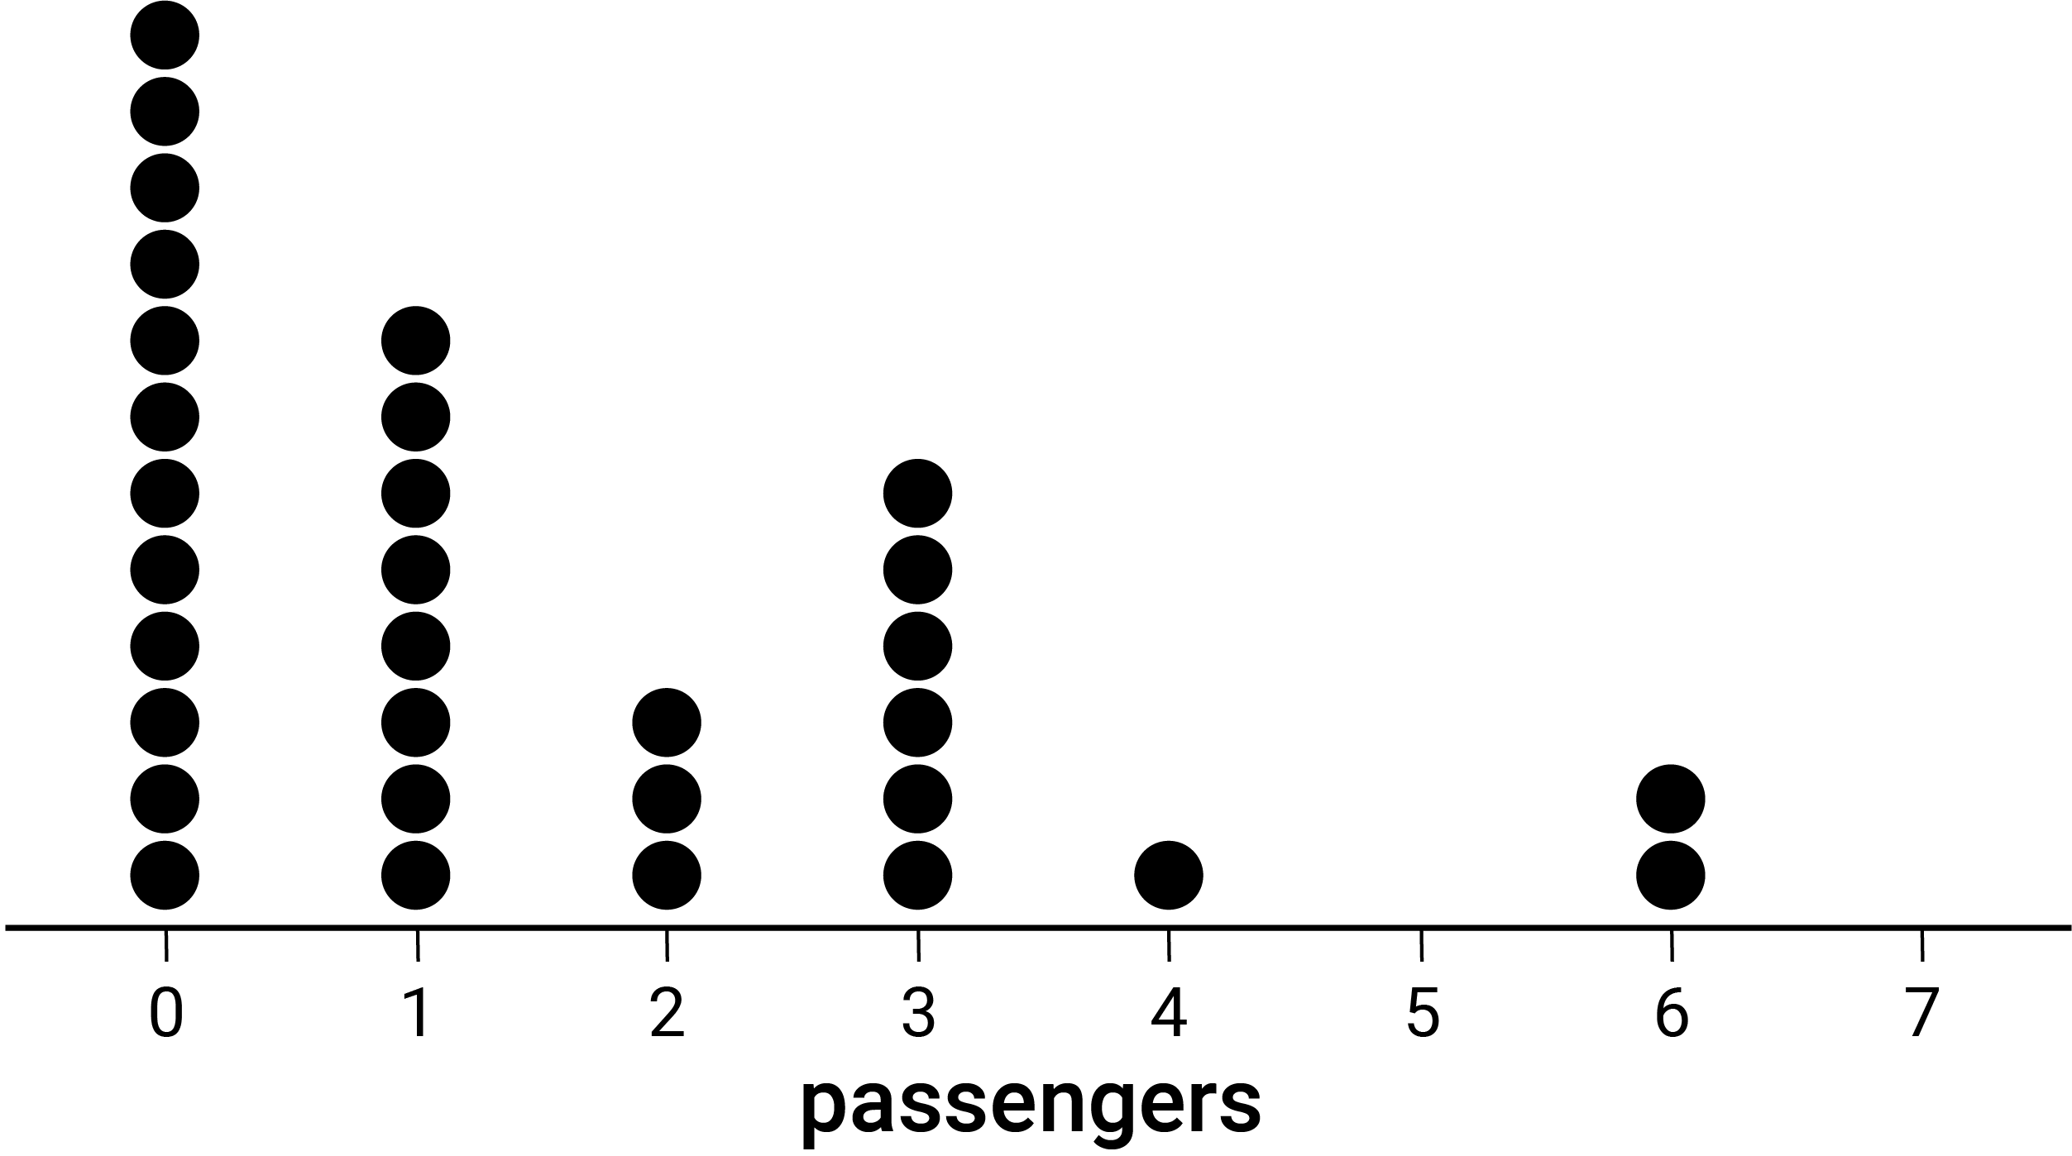
duration
A measure of time that an event or activity takes to complete.
dynamic geometric software
Software that supports the representation, construction and manipulation of geometric shapes and objects, and related measures and other functions in an interactive and dynamic digital environment.
E
efficient strategies
The choice of suitable approaches (mental, written, using digital tools), and methods within these. The means used for calculation reflect the purpose and context.
element(s)
A member of a set, e.g. $3$ is a member of the set of natural numbers $N = \{0, 1, 2, 3, ... \}$. This relation can be written more concisely as $3 ∈ N$ ('$3$ is an element of the set $N$').
enclosed spaces
Space that is enclosed by a boundary such as the perimeter of a shape or the outer surface area of an object.
enlargement transformation  A scaling of a figure in which the corresponding lengths in the transformed figure are increased or decreased in proportion to the original figure. The 2 figures are similar. | 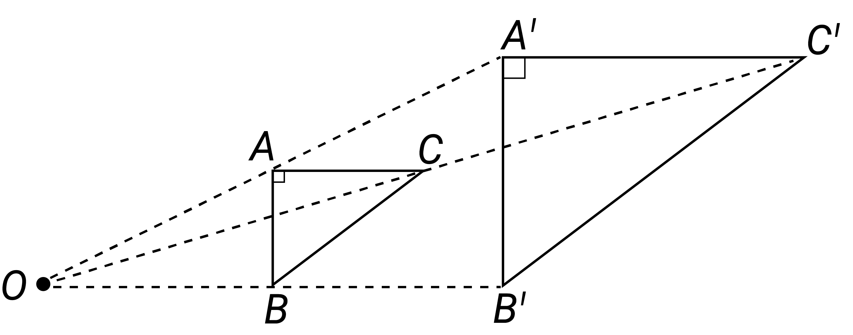
equal sharing
Dividing a collection, shape or object into equal parts.
equally likely outcomes
An event for which all outcomes have the same probability of occurring.
equation
A statement that includes the ‘=’ symbol. Equations are used to show the equality of 2 expressions.
equivalent
Equal in value or meaning. Something such as an expression or statement that is essentially the same. Two or more sets that are capable of being mapped in a one-to-one relationship.
equivalent fractions
Fractions that are different representations of the same value, e.g. $\frac{1}{2}=\frac{2}{4}=\frac{4}{8}$.
error
The difference between an actual value and its measured or estimated value.
estimation
The skill of conceptualising and mentally manipulating numbers or measurements to find an approximate answer. The capacity to make reasonable adjustments to estimates is essential in estimating.
estimation strategies
Strategies used to estimate or find an approximate value for the amount, extent, duration, position or size of something.
Euler's formula
A relation between the number of faces, vertices and edges of any polyhedron. It is written $F+V=E+2$, where $F$ is the number of faces, $V$ the number of vertices and $E$ the number of edges.
even number
An integer that is divisible by 2. The even natural numbers are $\{0, 2, 4, 6, …\}$
event
A subset of the sample space of a random experiment.
expanded notation
A way of representing a number, separating each digit and representing it in an additive number sentence to show each digit’s place value, e.g. $2345 = 2×1000+3×100+4×10+5$.
expected frequencies
The number of times that a particular event or outcome is predicted to occur using theoretical probability.
exponent
The power (or index) to which a number or algebraic expression is raised, shown using superscript, e.g. in the following expressions the exponent is $3: 2^{3}, 2x^{3}, 2({x+5)}^{3}$.
exponent laws
Rules for manipulating exponents. Also referred to as index laws.
exponential functions  Functions comprising a positive constant raised to the power of the variable; i.e. $f\left(x\right)= a^{x}$where $a$ is a constant and $x$ the variable. | 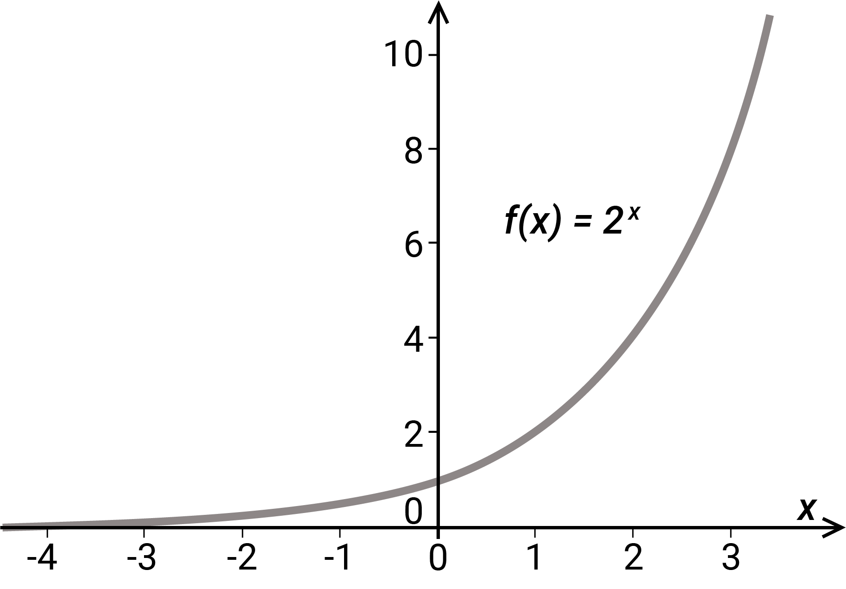
expression
Two or more numbers or variables connected by operations.
F
factors
Let a, b and c be natural numbers such that $a×b=c$, then $a$ and $b$ are factors (or divisors) of $c$, e.g. $3×4=12$, so $3$ and $4$ are factors (divisors) of $12$.
formulating expressions
The process of using mathematical notation, conventions and symbols to represent situations (including informal or worded statements) as mathematical expressions.
fraction
A number of the form $\frac{a}{b}$ where $a$ is an integer and $b$ is a non-zero integer, e.g. $\frac{4}{6}, \frac{11}{5}, \frac{-3}{7}$. A fraction is said to be in simplest form when $a$ and $b$ have no common divisor greater than $1$.
frequency
The number of times that a particular value occurs in a data set. For grouped data, it is the number of observations that lie in that group or class interval.
frequency table
A table listing the frequency (number of occurrences) of observations, measurements or outcomes in different ranges, called class intervals.
function
A correspondence (map or relation) between the elements of 2 sets where each element in the first set is mapped to exactly one corresponding element in the second set, either one-to-one or many-to-one.
function machine
An algorithmic process which takes an input, applies an operation (or operations) and results in an output.
G
geometric patterns
Patterns formed by a series of shapes. They may be repeating or growing patterns which change in predicted ways that can be generalised. Tessellations are geometric patterns formed by transforming shapes.
gradient
The slope of a line. It is calculated as the gradient of a line segment it contains. The gradient ($m$) of the line containing $A$($x_{1}, y_{1}$) and $B$($x_{2}, y_{2})$is calculated as $m=\frac{(y_{2}-y_{1})}{(x_{2}- x_{1})}$.
grid coordinate system  A system for referencing location within a space using labelled horizontal and vertical grid lines. Locations are defined using a set of coordinates which indicate points in the plane where 2 grid lines meet. | 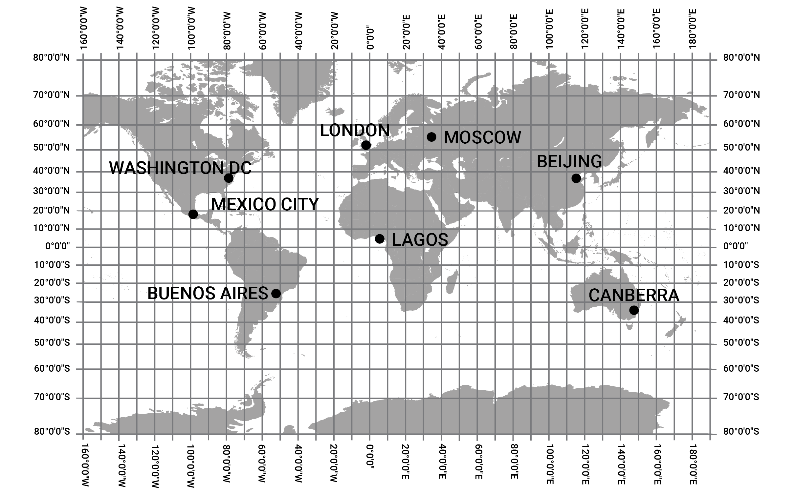
grid reference  A way of identifying a region on a map. Coordinates and grid lines are used to refer to specific features or locations, e.g. in the map shown, the school is located at the grid reference C4. | 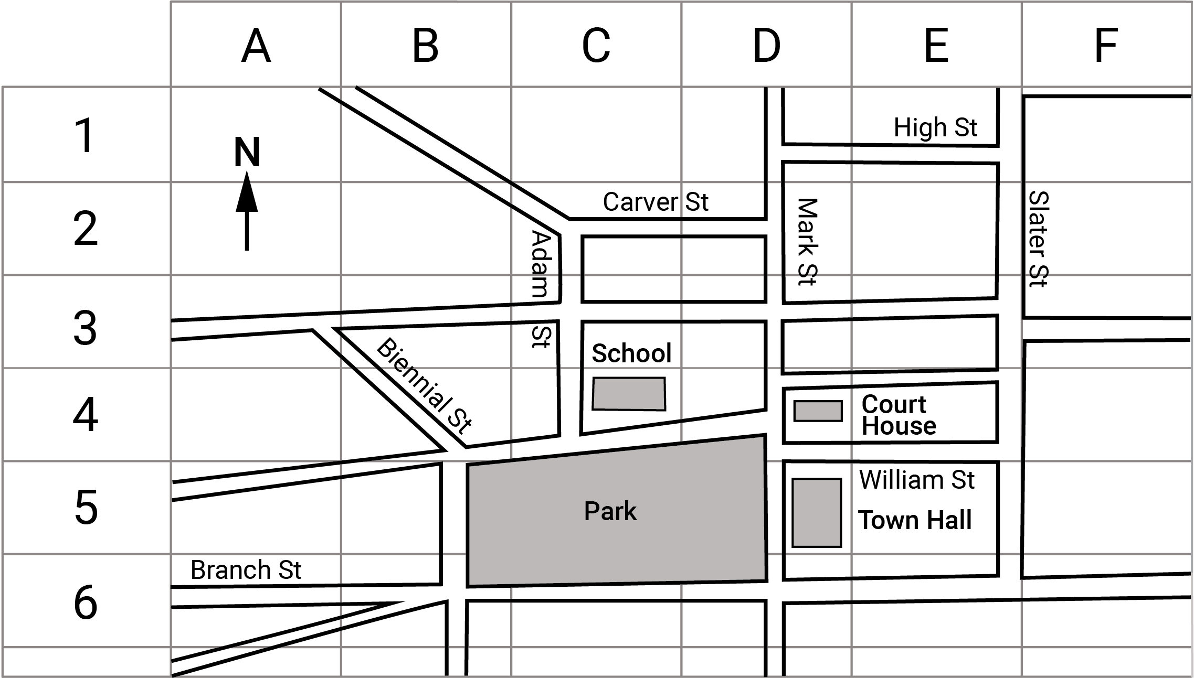
grouping
A process of partitioning a set into subsets according to a given criterion, e.g. a class of students according to eye colour. Equal grouping means each subset has the same number of elements.
growing pattern
A pattern where each term is either an increase or a decrease on the previous term. Change from term to term is predictable if the pattern is growing additively, multiplicatively or exponentially.
growth
A measure of the increase in value of the dependent variable of a function as the value of the independent variable increases, e.g. the length of a spring when weights are added.
guided statistical investigation
A teacher-led, scaffolded approach to the statistical investigation process including collecting, representing and analysing data, interpreting and communicating results.
H
histogram  A statistical graph for displaying the frequency distribution of continuous data. It is also a graphical representation of the information contained in a frequency table. | 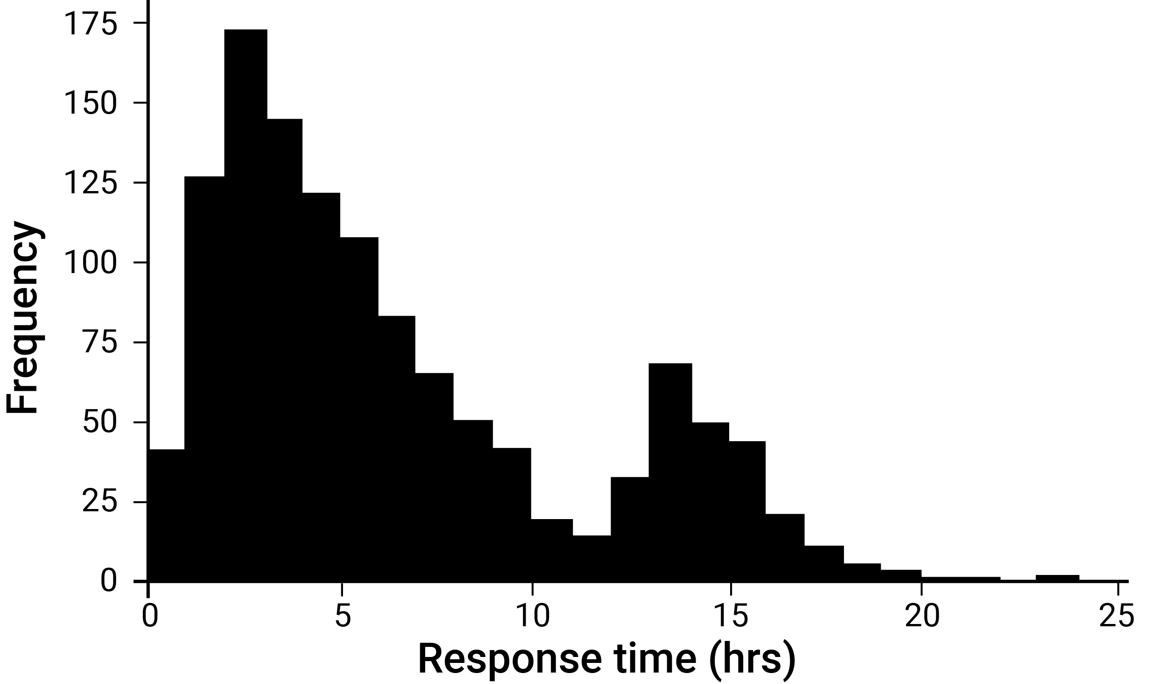
I
improper fraction
A fraction where the numerator is greater than or equal to the denominator, e.g. $\frac{7}{5}$ is an improper fraction, where as $\frac{5}{7}$ is a proper fraction.
inequality
A mathematical expression containing the terms ‘less than’, ‘less than or equal to’, ‘greater than’, or ‘greater than or equal to’ and their respective symbolic representations <, ≤, > and ≥.
inference (statistics)
The process for determining consequences or conclusions based on assumptions, evidence and reasoning.
informal units
Units whose values are decided on in a given context, e.g. the use of a pace to measure distance (non-uniform unit); the use of paperclips to measure length (uniform unit).
integer
An element of the infinite set of numbers $Z = \{... -3, -2, -1, 0, 1, 2, 3 ...\}$.
interval(s)
A continuous subset of the real number line, e.g. ‘the set of all real numbers greater than or equal to 10’.
inverse operation
An operation in arithmetic which undoes the effect of another operation. Multiplication and division are inverse operations, as are addition and subtraction.
irrational number
A number that cannot be expressed as a fraction in the form $\frac{m}{n}$, where $m$ and $n$ are integers and $n$ is non-zero. The decimal expansions of such numbers are infinite and non-recurring.
irregular object  An object that has faces of varying shapes. Contrast with a regular object such as a cube. | 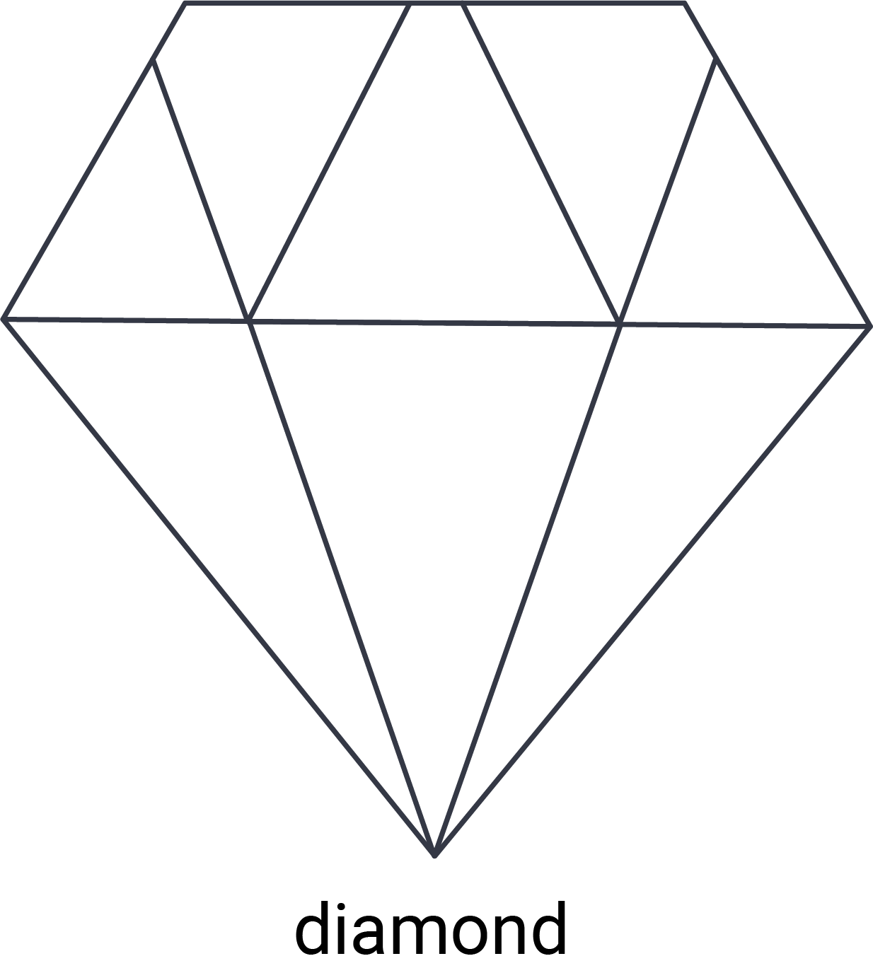
irregular shape  A shape with sides of varying lengths. Contrast with a regular shape such as a rhombus or equilateral triangle. | 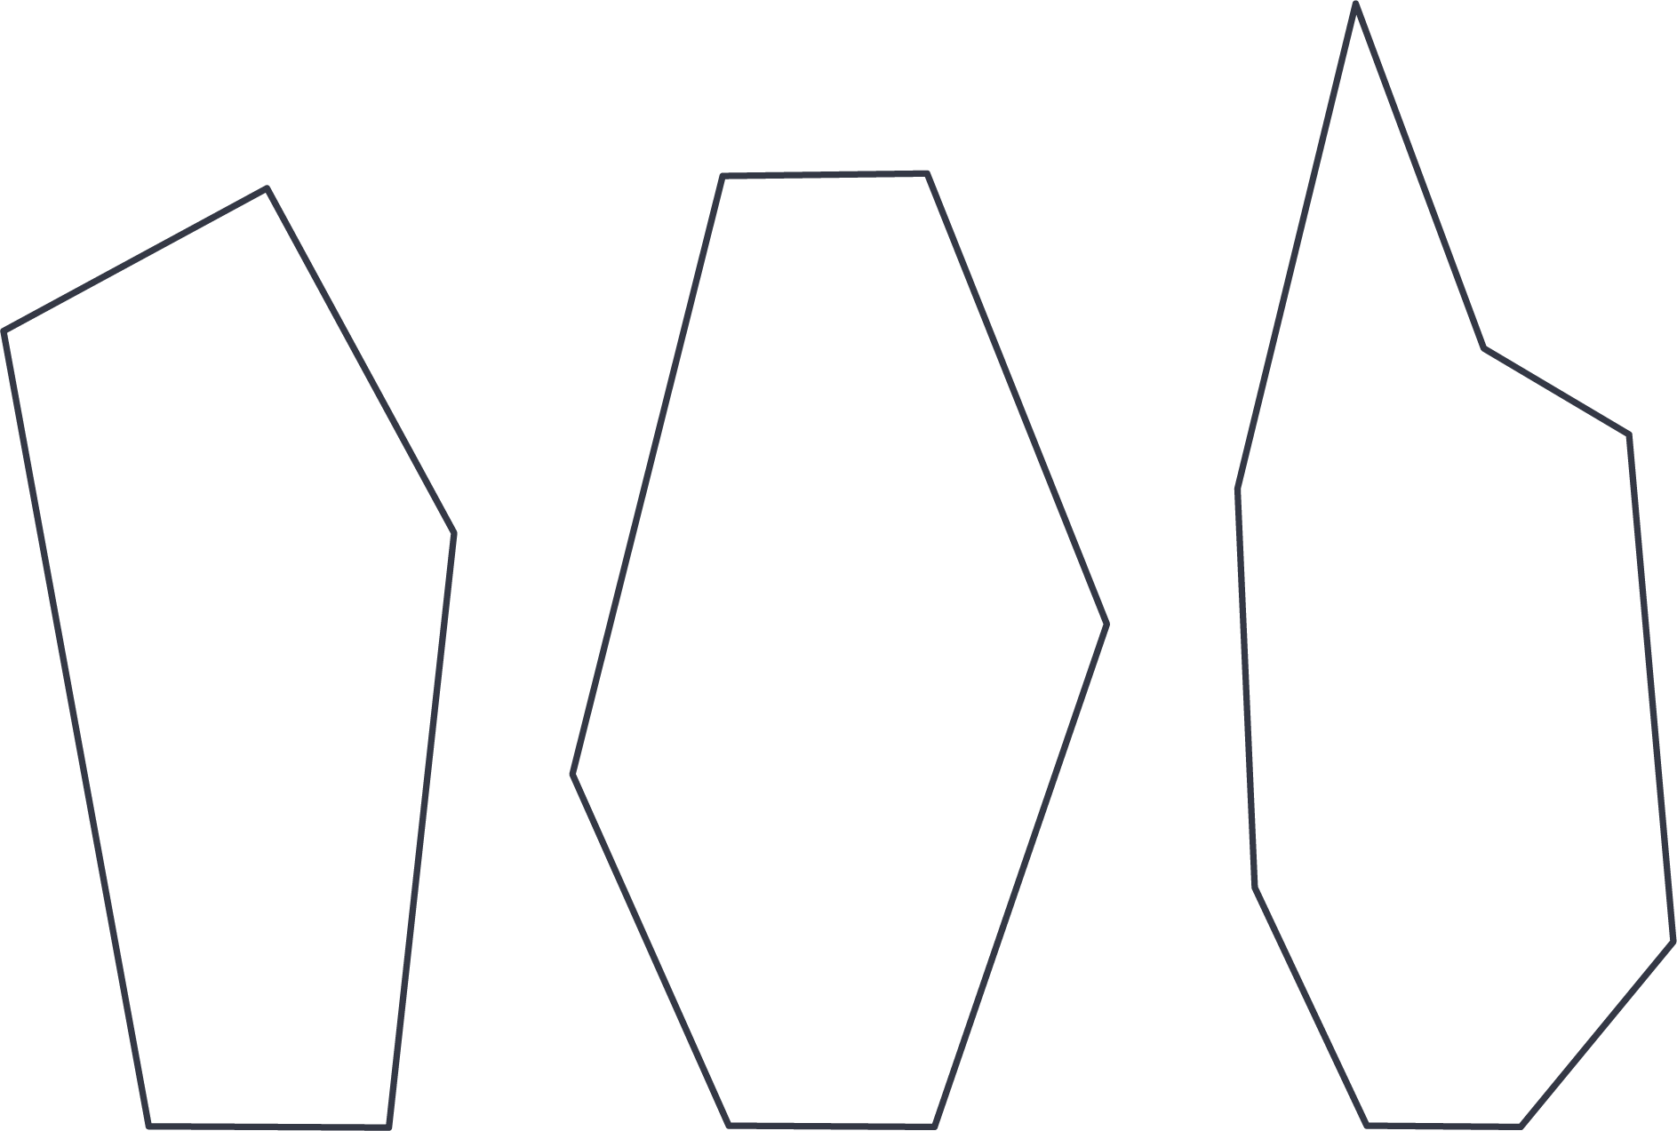
J
K
kinship
A system used to decide how people relate to each other and their roles, responsibilities and duties. A feature of First Nations Australians' social organisation and family relationships.
L
line
A model of what is perceived visually as straight. It has one dimension and extends indefinitely in the plane.
line graphs  Graphs that represent the changing relationship between 2 variables. They use lines to connect individual data points, and are generally used to show how something changes over time. | 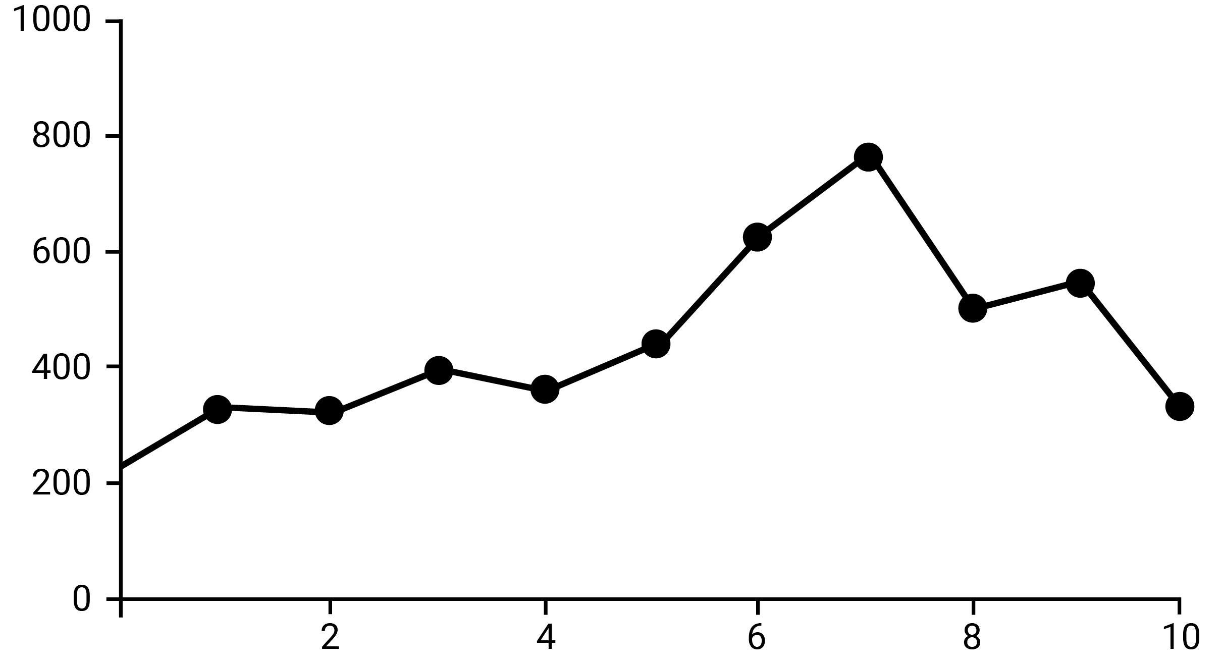
line segment (interval)
Let $A$and $B$ be 2 distinct points on a line, then the part of the line between and including $A$ and $B$ is a line segment.
line symmetry  A line in which a shape is symmetrical such that if you were to fold the shape about this line it would map onto itself exactly. | 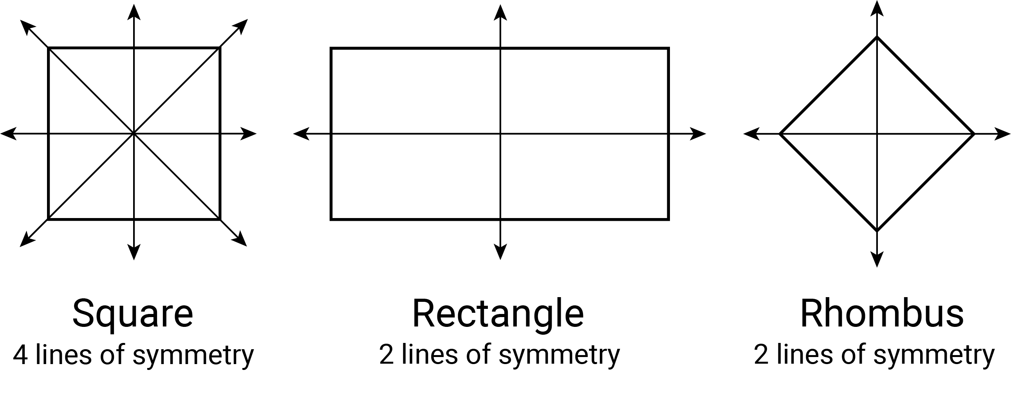
linear equations
Equations involving linear expressions. The general form of a linear equation in one variable is $ax+b=c$ where $a, b$ and $c$ are constants.
linear expression
An expression involving only variables to the power 1, and constants, e.g.
$2x+3, 180(n-2)$, $4x-5y$.
linear functions
A function which when graphed on a Cartesian plane produces a straight line. It can be reduced to the general form $y=mx+b$.
linear inequalities
Inequalities that involve linear expressions and contain one of the inequality signs: either $< , > , ≤$ or $≥$.
logarithmic scales  Scales where successive endpoint values of intervals increase by a constant factor (multiplicatively). Contrast with linear scales in which the increase is a constant amount. | 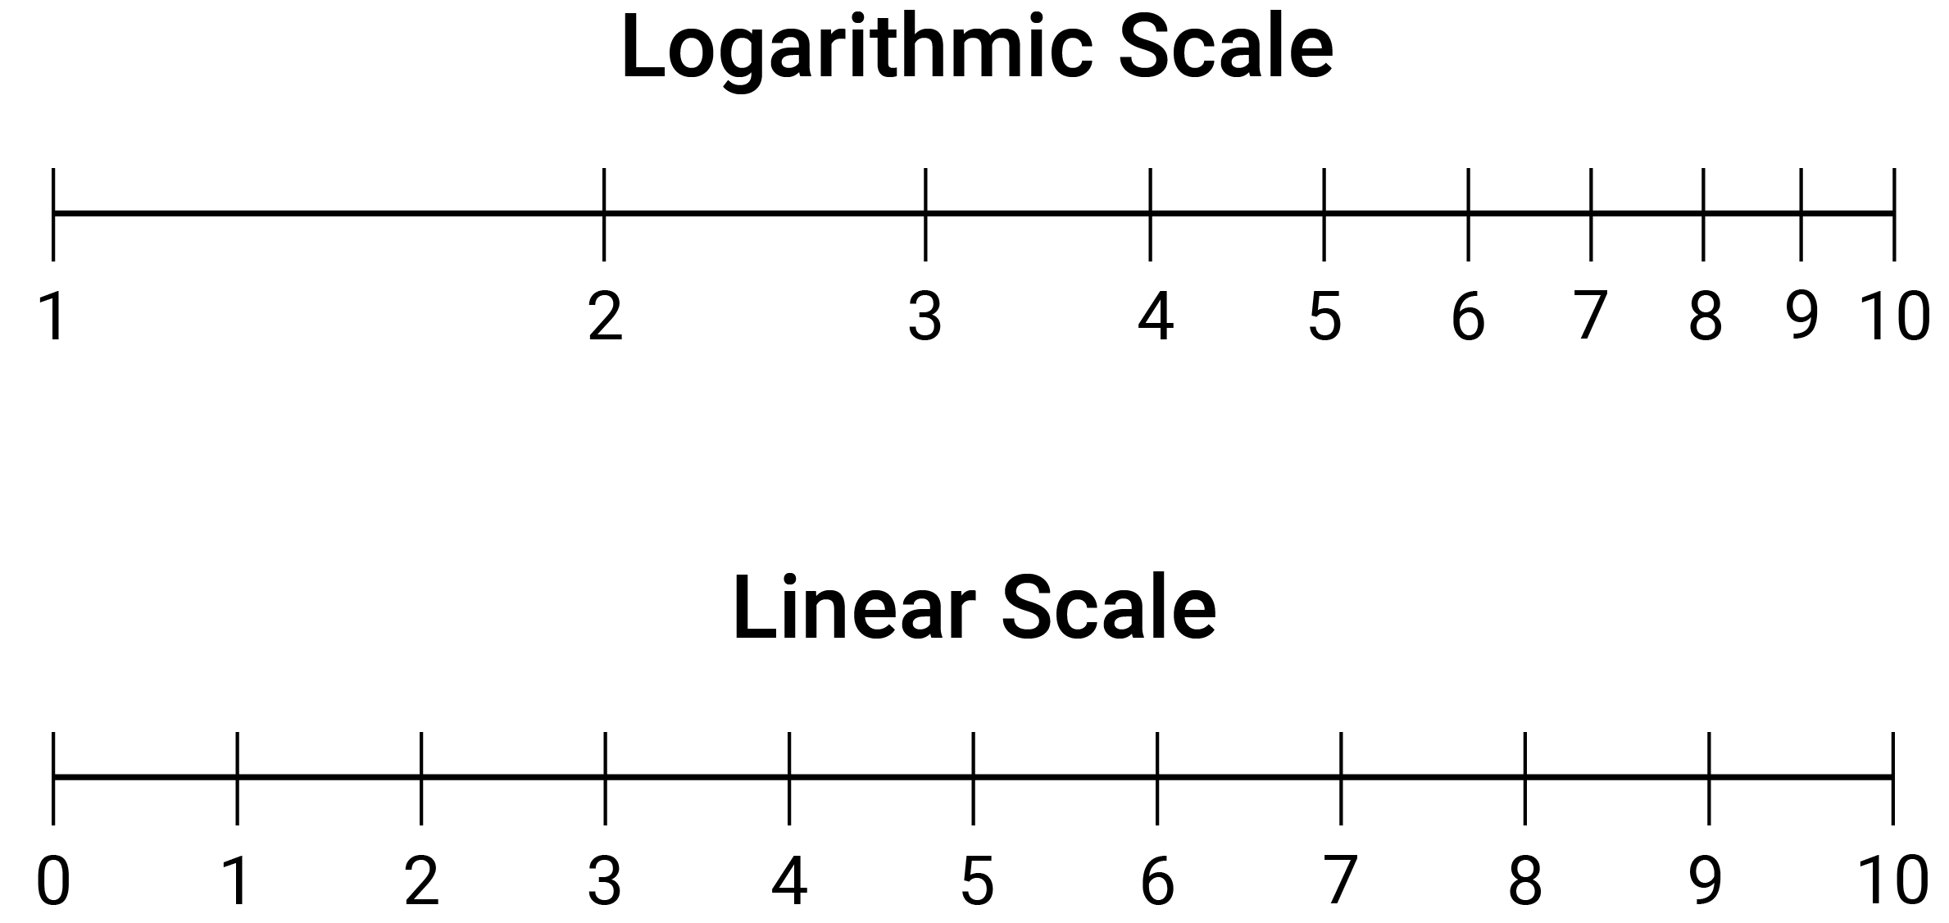
M
mass
The measure for how much matter an object contains. The SI unit for mass is the kilogram (kg).
mean
The sum of values in a data set divided by the total number of values in the data set. Also called the average.
measure
A record of the magnitude of an attribute (such as weight, length, duration and likelihood) associated with an object or event.
measure of central tendency
A statistic that is used to summarise a data set. There are 3 common measures of centre for a data set: mode, median and mean.
measure of turn
A measurement of rotation from an initial starting position. A turn can be a fraction of a circle (quarter turn) or complete rotation (revolution). It can be directional (clockwise or anti-clockwise).
median
The value in a set of ordered data that divides the data into 2 equal parts. It is often called the ‘middle value’.
mixed numeral
A form of representation of a rational number (also called a mixed fraction or mixed number) composed of an integer and a proper fraction, i.e. a fraction with a smaller numerator than denominator, e.g.$2\frac{3}{5}$.
mode
The most frequently occurring value in a set of data. There can be more than one mode. When there are 2 modes, the data set is said to be bimodal.
mathematical modelling
A mathematical process involving the identification of a real-world problem, formulating and finding a solution to the problem mathematically using knowledge and understanding of mathematical concepts, structures and relationships, interpreting and communicating the mathematical solution(s) in terms of the situation. As students mathematical modelling skills become more sophisticated they begin to consider assumptions, choose variables, justify decisions and evaluate the effectiveness of the model.
modelling
Using mathematical concepts, structures and relationships to describe and characterise, or model, a situation in a way that captures its essential features.
multiples
A multiple of a number is the product of that number and an integer. A multiple of a real number $x$ is any number that is a product of $x$ and an integer.
multiplication facts
The results associated with the products of pairs of natural numbers from 0 to 9, associated with reasons. They are foundational to arithmetic.
multiplicative
Problems or contexts that involve multiplication or division, e.g. calculating the number of seats in a theatre that has 30 rows of 24 seats.
N
natural numbers
The set $N = \{0, 1, 2, 3 …\}$ or $N = \{1, 2, 3 …\}$ depending on whether counting is started at $0$ or $1$. The elements of $N$ are also called the counting numbers, used to count the number of elements in finite sets.
nets  Plane figures that can be folded to form a polyhedron. More specifically, 2-dimensional representations comprising joined shapes (the faces) that can be folded (along edges) to form the object. | 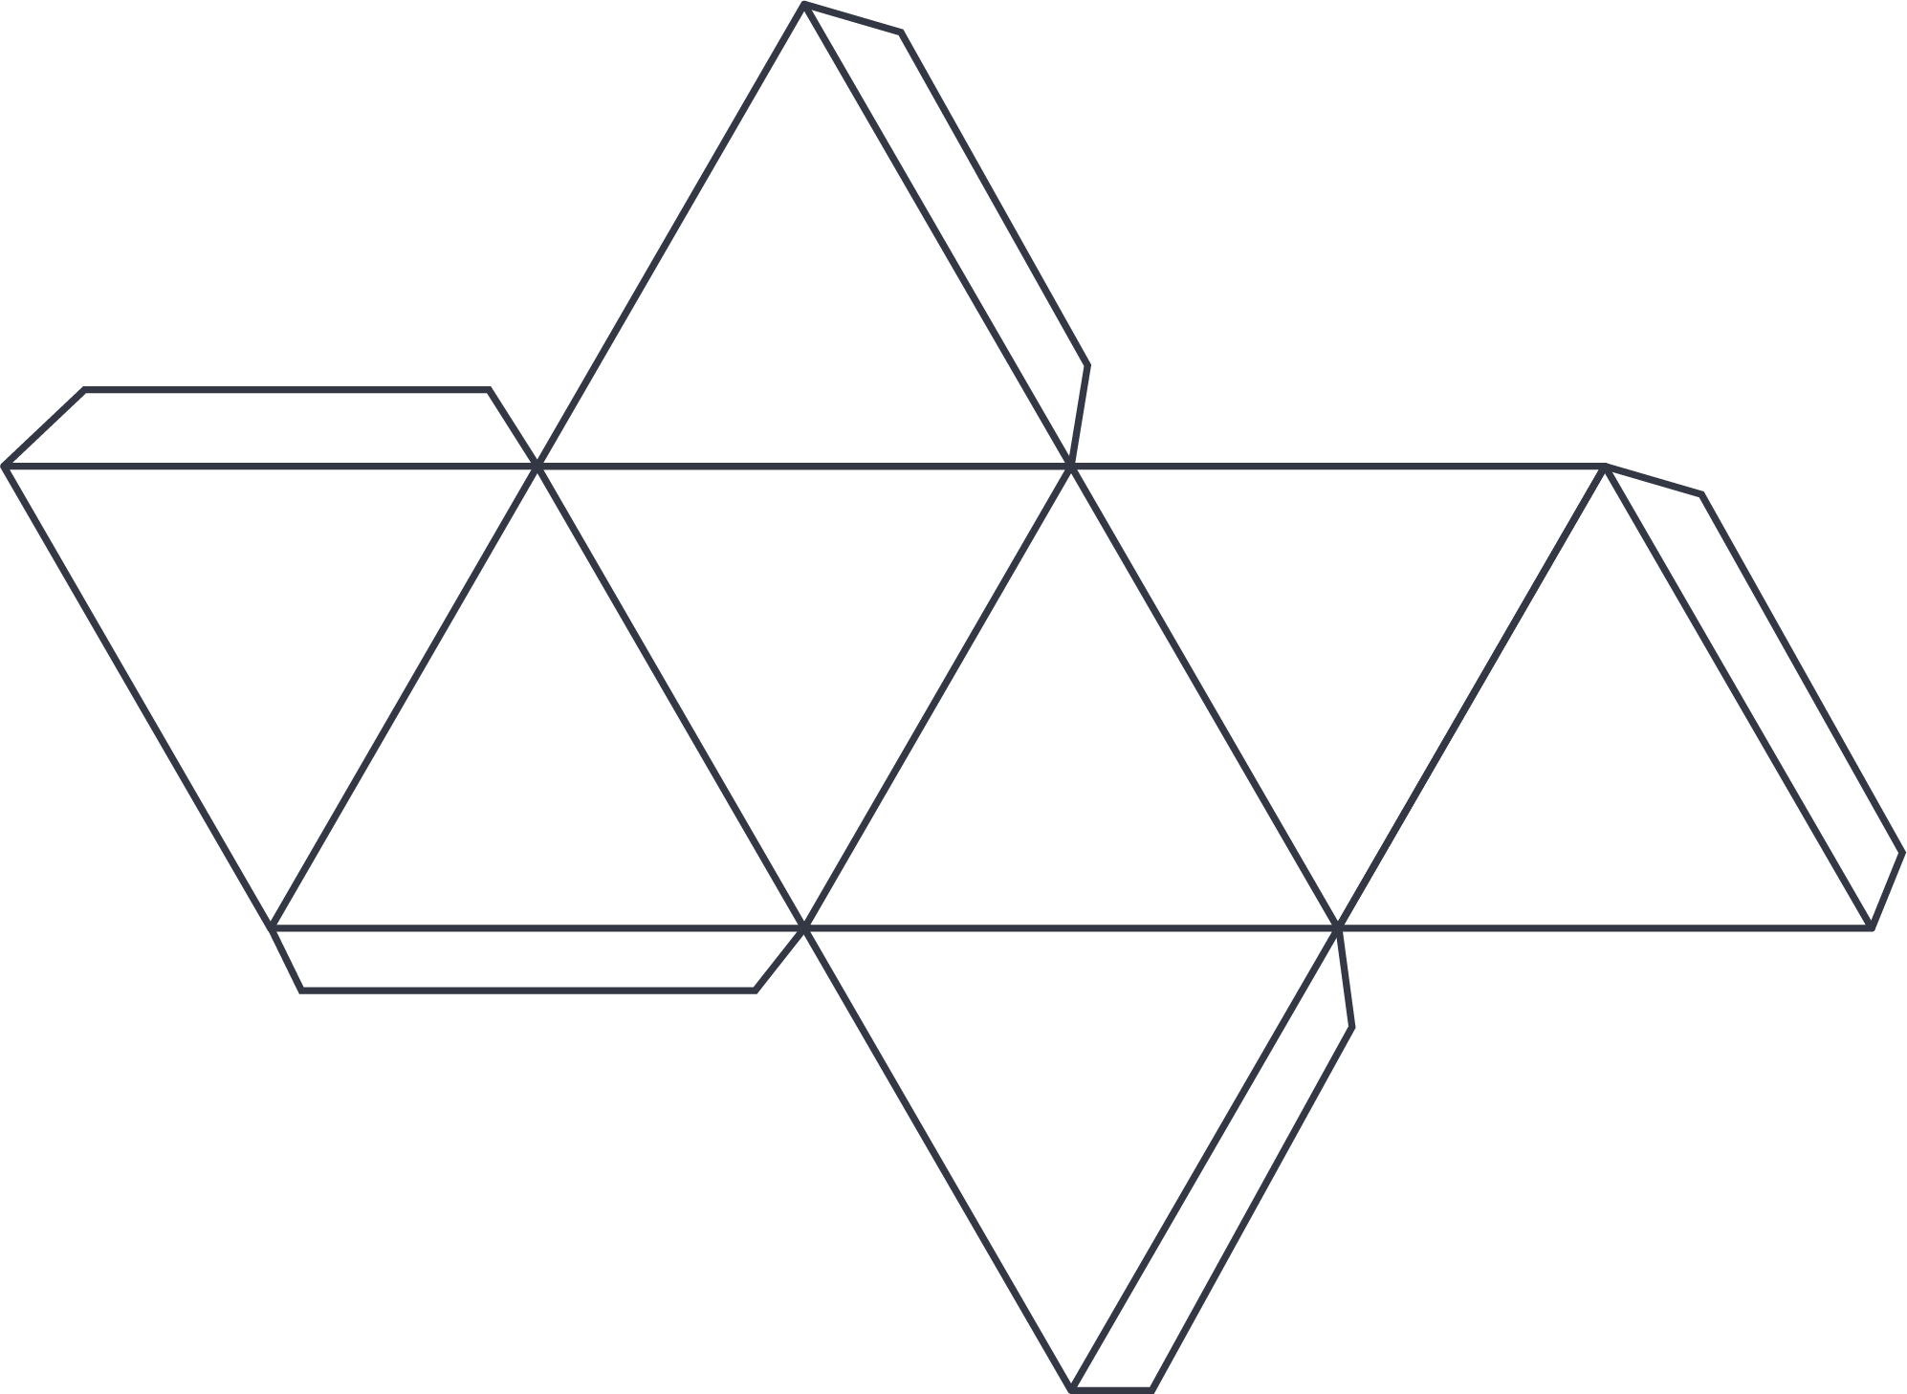
network  A set of points (vertices or nodes) some of which are joined by lines or curves (edges) which sometimes enclose regions (faces), e.g. road networks, a family tree or the edges lining a tennis court. | 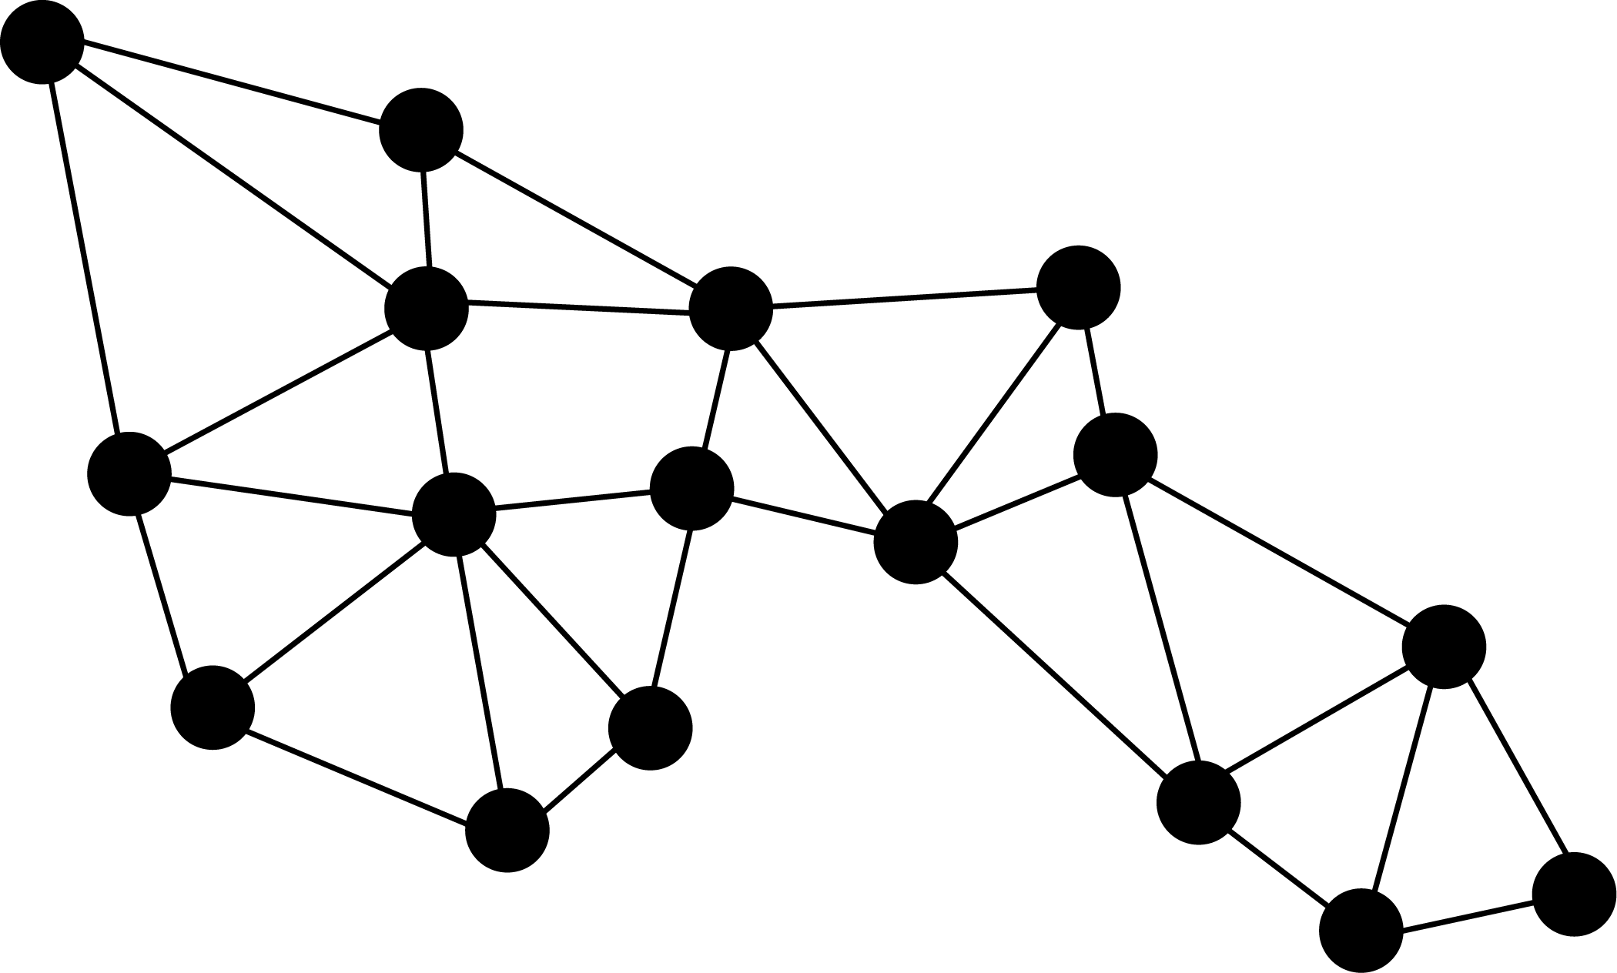
number line
A line that gives a pictorial representation of real numbers.
number sentence
A statement of equality or inequality using numbers, operations and common symbols,
e.g. $8+5=13$ and $16 – ☐= 10$
numeral
The designation of a number in a given language, e.g. the number ‘three’ is designated by the Hindu-Arabic numeral 3, the Roman numeral III, and the Chinese numeral 三.
numerical data
Data associated with a numerical variable. It can be discrete or continuous, e.g. number of siblings in a family or heights of students in the class.
numerical variables
Variables with values that are numbers, and for which measuring and arithmetic processes such as adding and subtracting, or calculating an average, make sense.
O
object
A solid or 3-dimensional skeletal representation composed of a number of faces, edges, vertices or closed surfaces, such as a prism, pyramid, cylinder or sphere. The term 3-dimensional shape is also used.
obtuse angle
An angle that measures between 90 and 180 degrees, i.e. between one and 2 right angles.
odd number
An integer that is not divisible by $2$. The odd numbers are $\{… -5, -3,-1, 1, 3, 5, …\}$.
online tools
Digital hardware, software, platforms and resources that are connected and support communications between users. Examples of online tools include websites for online shopping and fitness apps.
operation
The process of combining numbers or expressions. Operations are arithmetic – addition, subtraction, multiplication and division – and also include exponentiation and substitution.
order of operations
A set of conventions for evaluating expressions involving several operations. Operations in brackets are first, followed by exponents, multiplication/division, then addition/subtraction left to right.
ordinal categorical data
Categorical data that has a ranking or order such as Likert scales, clothing sizes, placegetters in a race.
outlier  A data value that appears to stand out from the other members of the data set by being unusually high or low. | 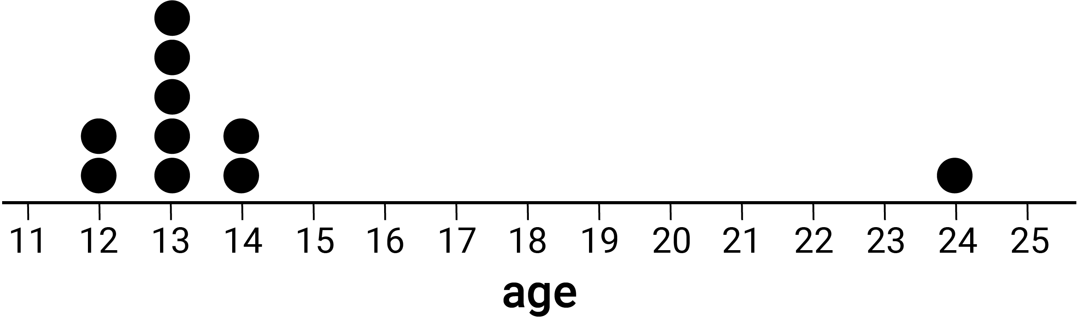

P
parallel lines  Two lines L and M in a plane that have no point of intersection in that plane, written L $||$ M. | 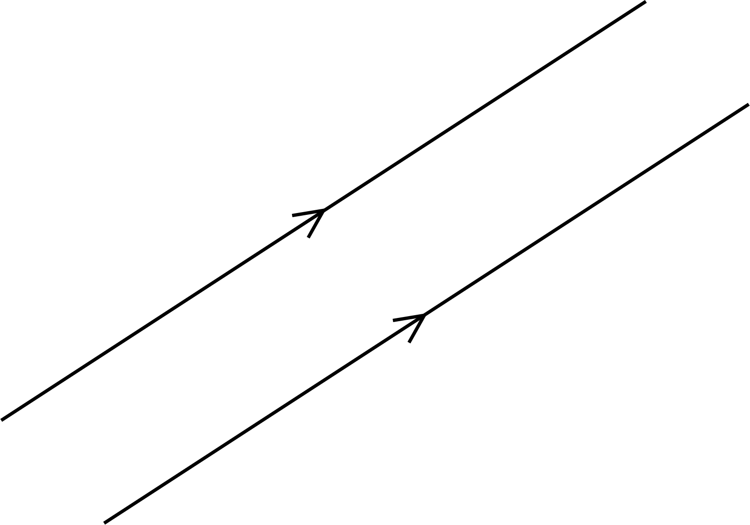
parallelogram  A quadrilateral in which opposite sides are parallel and equal in length. The quadrilateral ABCD shown is a parallelogram because BA $||$ CD and AD $||$ BC. | 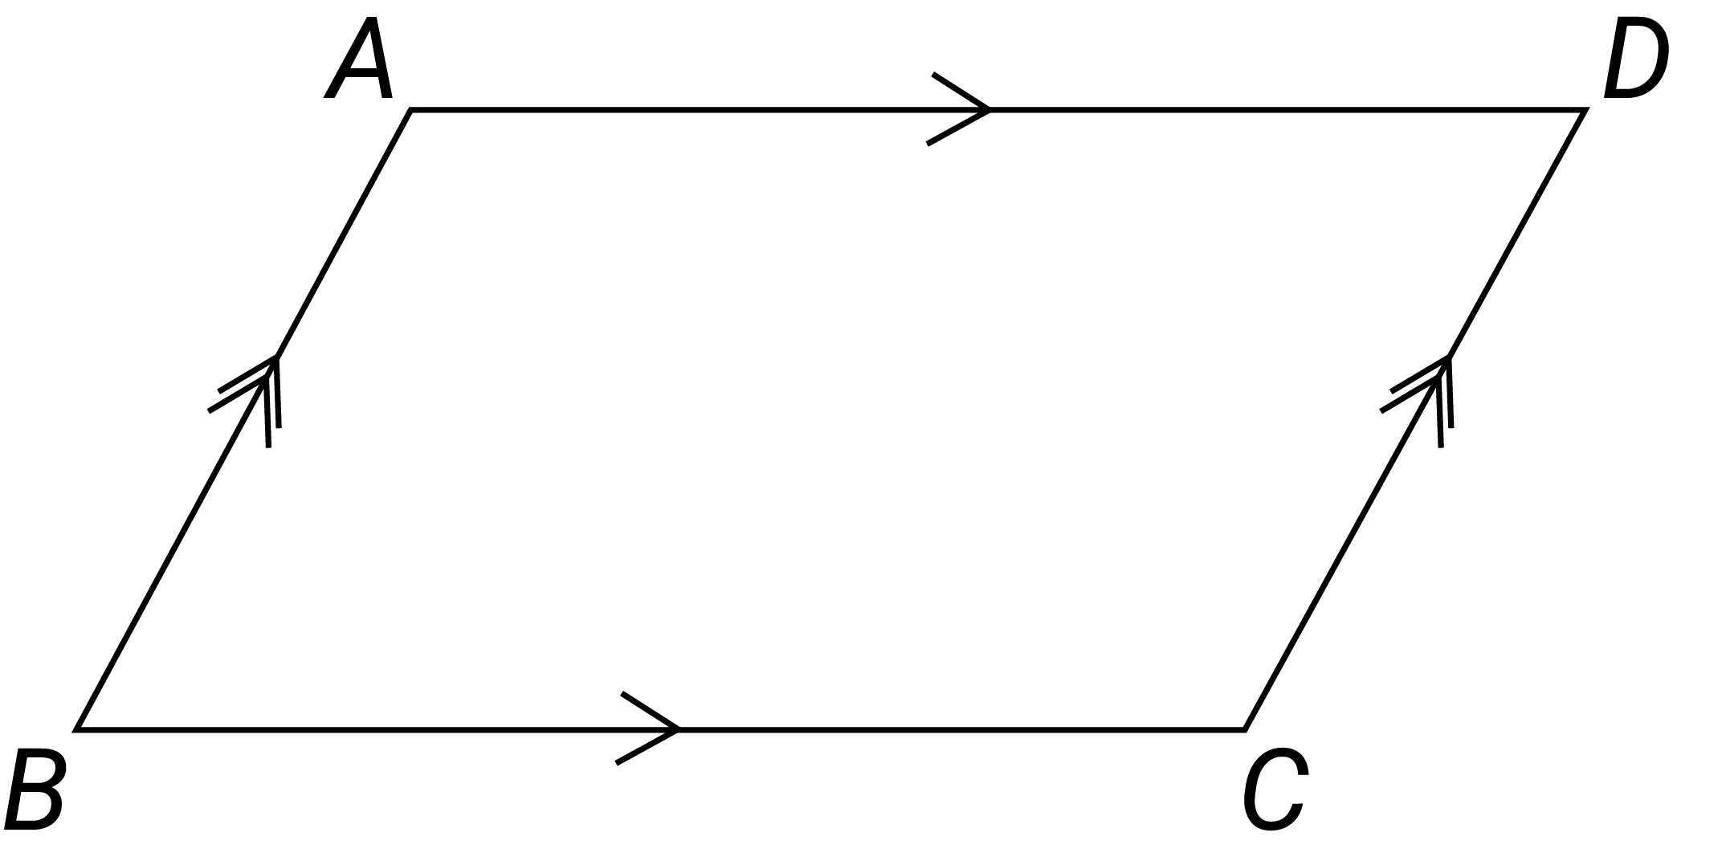
parameters
A factor for which a specific value defines a condition or constraint for a function or relation.
partition numbers
Separating numbers additively or multiplicatively into 2 or more parts, e.g. $10$ is $8+2$,
$8$ is $3+3+2$; $12$ divided into $6$ equal parts of $2$, $12=6×2, 12÷6=2, 12=3×4, 12÷3=4$.
partitioning
The ability to think about numbers as made up of 2 or more parts. Numbers can be partitioned into standard or non-standard place value partitions such as $248$ as $200+40+8$ or $62$ as $50+10+2.$
part-part-whole reasoning
A model used to recognise relationships between a whole number and its parts, e.g. $7=5+2$ or $7=4+3$.
percentage
A ratio to 100 or a fraction whose denominator is 100.
perfect square
A number that is the square of an integer, e.g. $169$is a perfect square as ${13}^{2}=169$. Perfect squares can also be represented pictorially.
perimeter
The total length of the boundary of a plane figure or space.
perpendicular
Two lines, rays, line segments, vectors, planes or other objects that intersect at a 90° angle (a right angle) are considered perpendicular.
pi ($π$)
The ratio of the circumference of any circle to its diameter. It is denoted by the Greek letter $π$ (pi). Approximate values are $3.14$ or $\frac{22}{7}$.
picture graph (pictographs)  A statistical graph for organising and displaying categorical data. | 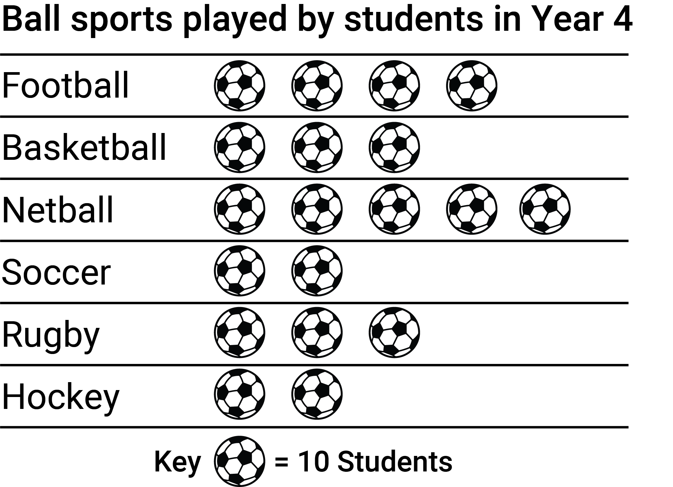
place value
The value of a digit as determined by its position in a number relative to the ones (or units) place. For integers, the ones place is occupied by the rightmost digit in the number.
planar graph  A connected graph that is drawn within a plane whose edges do not cross. | 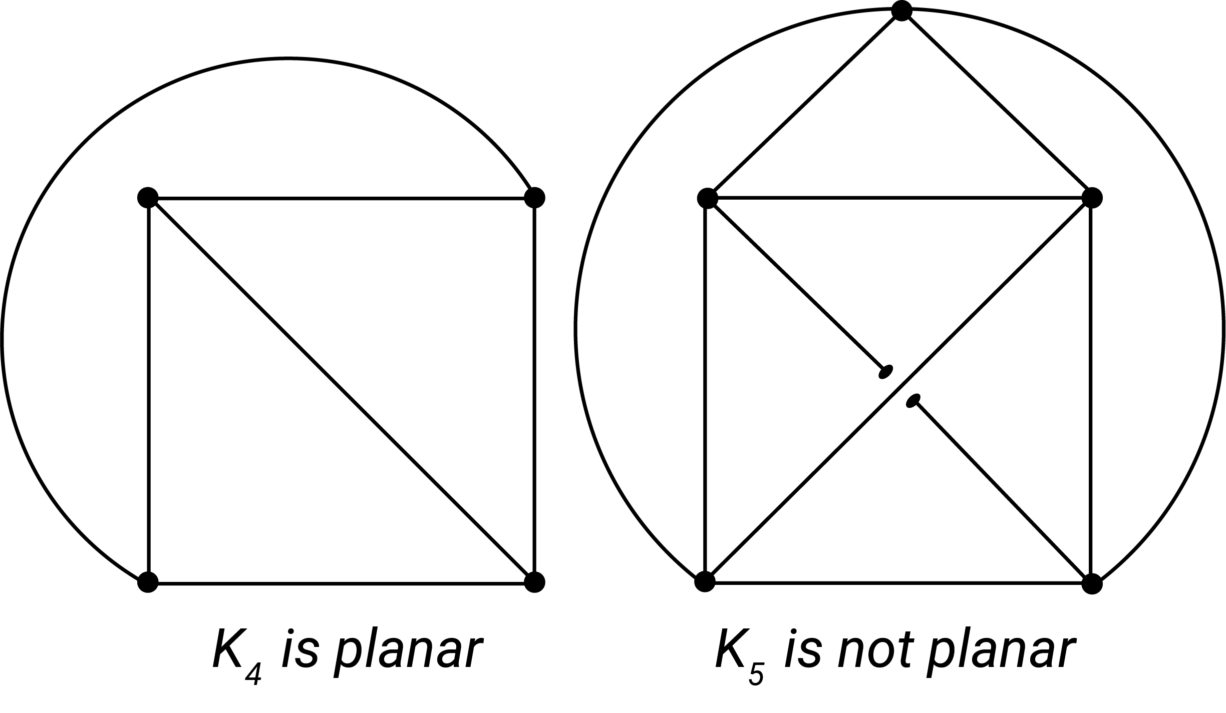
platonic solids
Three-dimensional, convex and regular objects that have polygonal faces. The 5 platonic solids are the tetrahedron, cube, octahedron, dodecahedron and icosahedron.
point
Representation of a location in space that has zero dimensions. Lines, curves, shapes, surfaces and objects are constructed from sets of points. Points in the Cartesian plane are specified by coordinates.
polyhedra
Three-dimensional objects whose faces are adjacent polygons. A convex polyhedron is a finite region bounded by planes, in the sense that the region lies entirely on one side of the plane.
population
The complete set of individuals, objects, places, etc. that we want information about. A census collects information about the whole population.
prime number
A natural number that is greater than 1 and its only factors are 1 and itself.
prism
A convex polyhedron that has 2 congruent and parallel polygonal faces; all its other faces are parallelograms. It is named according to these 2 congruent faces, e.g. a triangular prism.
probability
The chance of something happening shown on a scale from 0 and 1 (inclusive), e.g. the probability that a fair coin toss will come up ‘heads’ is 0.5.
product
The result of multiplying together 2 or more numbers or algebraic expressions.
proof
A mathematical argument that demonstrates whether a proposition is true. A mathematical statement which has been proved is called a theorem.
proportion
A constant ratio between corresponding elements of 2 sets, e.g. the circumference and diameter of a circle are in proportion as their ratio is the constant $π$ (pi).
Pythagoras's theorem  The square of the length of the hypotenuse, $c$, of a right-angled triangle equals the sum of the squares of the lengths of the other 2 sides, $a$ and $b$, such that $c^{2}=a^{2}+b^{2}$. | 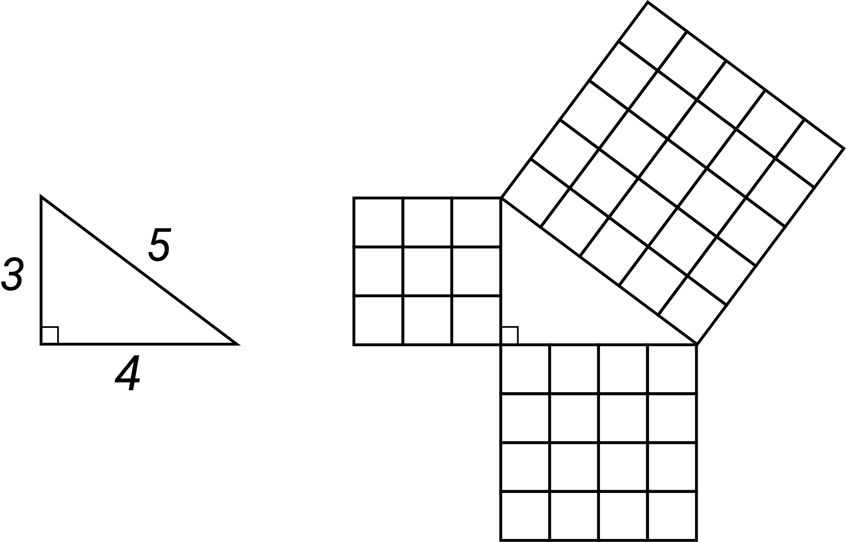
Q
quadratic equation
A quadratic expression that has a particular value. The general quadratic equation in one variable is $ax^{2}+bx+c=0$, for constants $a, b, c$ and where $a≠0$.
quadratic expression
An expression that contains one or more of the terms in which the variable is raised to the second power, but no variable is raised to a higher power. Its general form is $ax^{2}+bx+c$, where $a≠0$.
quadratic function
A function in which the rule is a quadratic expression. When graphed in the Cartesian plane it produces a parabola and algebraically it can be represented in the form $y=ax^{2}+bx+c$ where $a≠0$.
quadrilateral
A four-sided polygon. Examples include square (a regular quadrilateral, all sides and angles equal), rectangle, kite and trapezium.
quotient
The result of dividing one number or algebraic expression by another.
R
radius  The distance from the centre to the circumference of a circle. | 
random sample
A subset of the population chosen such that every element of the population has an equal chance of being selected; i.e. their selection is governed by chance, e.g. by using a random number generator.
random variable
A function that assigns real numbers to random events.
range
A set of different things of the same general type, e.g. different representations of the same fraction or a variety of strategies for solving problems involving the basic operations.
Statistics: the difference between the largest and smallest numerical values in a data set. It can be used as a measure of spread in a data set. It is sensitive to outliers and should be interpreted with care.
rate
A comparison of 2 quantities measured in different units, e.g. the rate of distance to time, known as speed, because distance and time are measured in different units (such as kilometres and hours).
ratio
A comparison of magnitudes of sets, quantities of the same kind or algebraic expressions. It is often used as a comparison $a∶b$ of the size of 2 (or more) quantities relative to each other.
rational number
An element of the infinite set of numbers $Q=$ {$\frac{m}{n}$, where$m$ and $n$ are integers and $n$ ≠ zero}. It may be expressed in decimal form, e.g. $\frac{1}{8}=0.125$and $\frac{4}{9}=0.444…$
real number line
The representation of real numbers using the infinite set of points on a continuous line.
real numbers
The numbers generally used in mathematics, scientific work and everyday life. They are any of the elements of the infinite set $R$, which includes all the rational numbers and irrational numbers.
reasonableness (calculation)
Checking the results of calculations or operations to see if they are reasonable in the context, e.g. the sum of 2 odd natural numbers must be an even number.
rectangle
A quadrilateral in which all angles are right angles.
recurring decimal
A decimal expansion of a number that contains a finite sequence of digits that repeats indefinitely, such as $34.271271271 ...$ The repeating sequence is often designated by a bar over it, such as $34.\overline{271}$.
reflection
A transformation where each point of a shape is mirrored to a position the same distance from an axis of symmetry.
reflex angle  An angle that measures between 180 and 360 degrees, i.e. between 2 and 4 right angles. | 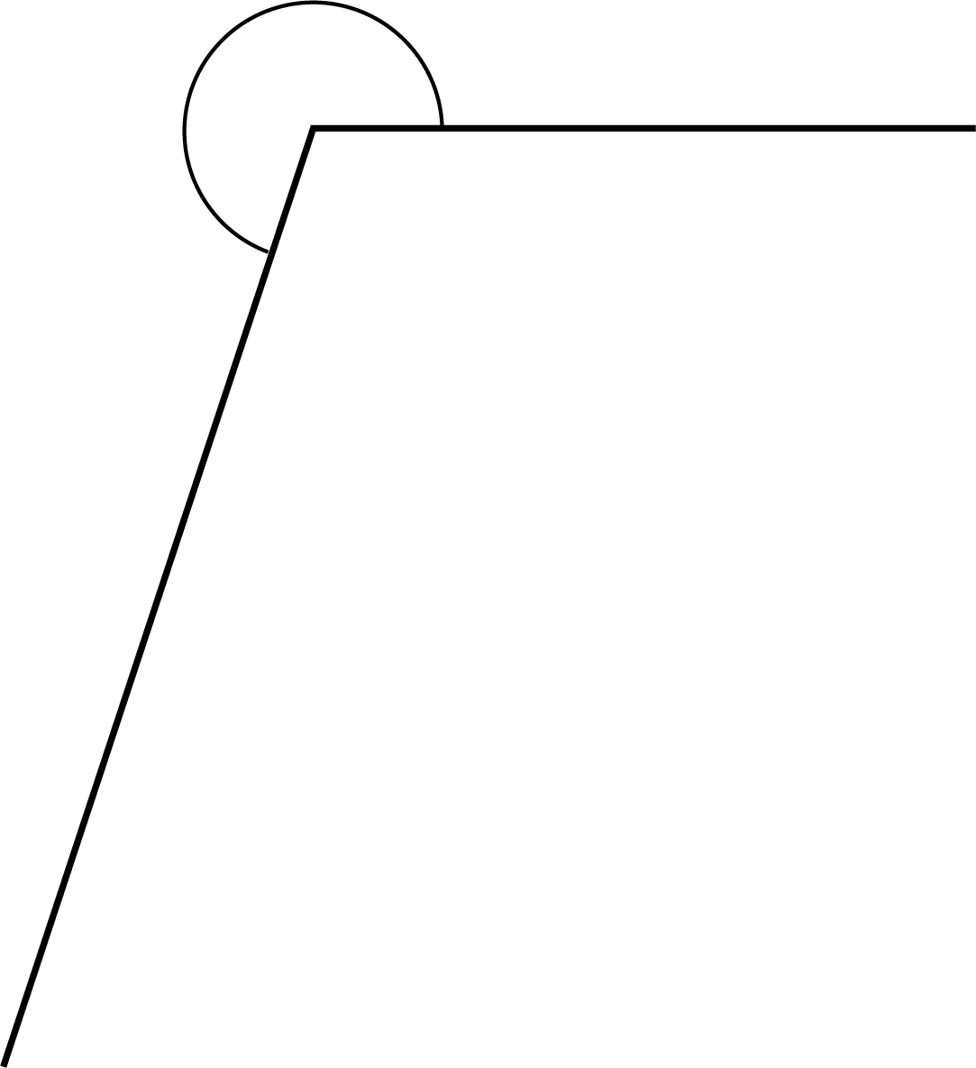
regular shape
A shape that has all sides of equal length, and all interior angles equal.
related denominators
One of the denominators is a multiple of the other denominator of a pair of fractions.
relation
A correspondence (map) between the elements of 2 sets, e.g. ‘favourite colour’ related to the set of students in a class (the domain) and the set of colours (the co-domain).
rename
To express a number according to the relationship between the place value powers of 10, e.g. 263 can be renamed 2 hundreds and 63 ones or 1 hundred, 16 tens and 3 ones.
repeated addition
Adding the same number several times, e.g. $3+3+3+3=4×3=12$. A strategy sometimes used for multiplication.
repeating pattern
A pattern where there is an identifiable repeating unit such as beads arranged in a sequence of red, green, blue, red, green, blue …; days of the week or months of the year.
revolution
A complete turn around a point.
right angle
An angle formed by a quarter turn of a revolution. It is equal to 90 degrees. If 2 lines are at a right angle, they may also be referred to as being perpendicular.
right prism
Convex polyhedra that have 2 congruent and parallel faces and all remaining faces are congruent rectangles.
rotation  A transformation where each point in the plane is rotated through a given angle about a fixed point in the plane (the point or centre of rotation). For example, the point A is rotated 120$°$ clockwise and 60$°$ anti-clockwise. | 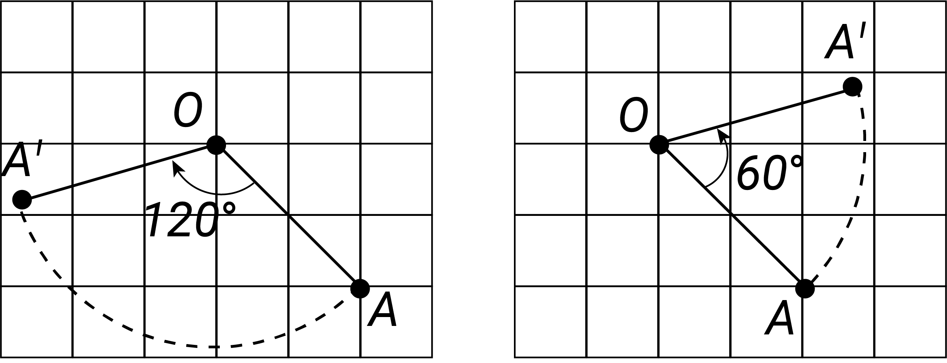
rotational symmetry  A quality of some shapes and objects to appear the same when turned around their centre for less than a full turn, e.g. a square has quarter-turn rotational symmetry. | 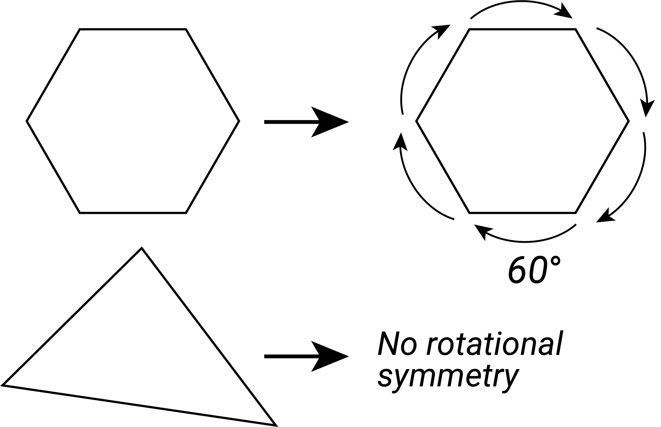
rounding
The process for approximating a value that lies between 2 known values. It is used to specify a number correct to a given accuracy, e.g. 4.027 becomes 4.03 when rounded to 2 decimal places.

S
sample
A subset of a population used to estimate characteristics of the population, e.g. a randomly selected group of 8 year olds (sample) selected to estimate the height of 8 year olds in Australia (population).
sample space
The set of all possible outcomes of a chance experiment, e.g. the set of outcomes (also called sample points) from tossing 2 heads is {HH, HT, TH, TT}, where H represents a ‘head’ and T a ‘tail’.
sampling
A process by which a subset of a population is selected for the purposes of data analysis. This subset is called a sample.
scale
Specification of proportion between 2 measures, e.g. a model of a house may be made on a 1:10 scale of length; on a graph, each interval of the vertical axis corresponds to a given value.
scatter plot  A visual representation of bivariate numerical data using the position of each dot on the horizontal and vertical axis to indicate the numerical values for an individual data point. Scatter plots are used to observe relationships between variables. | 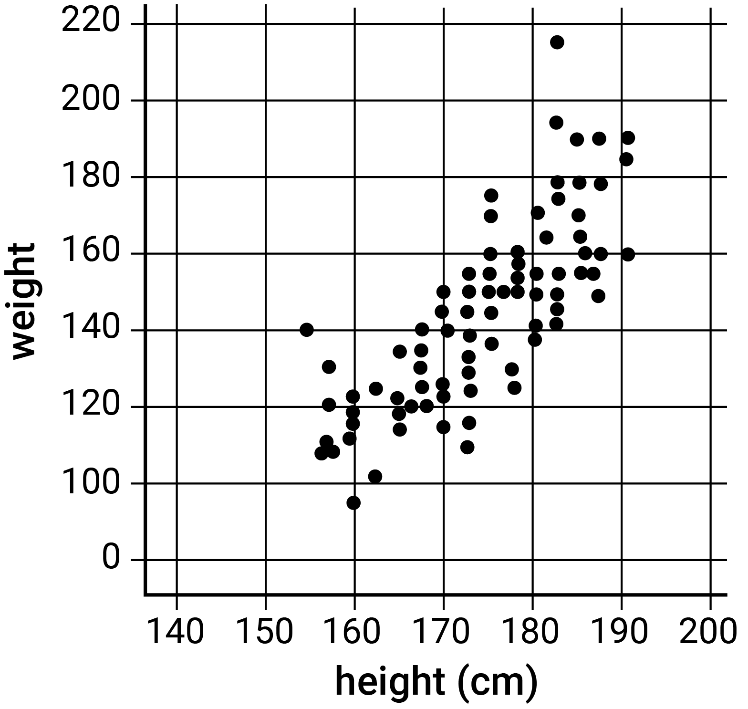
scientific notation
A way of writing numbers that are too big or too small to be written in an accessible way. It uses powers of 10, e.g. the scientific notation for 34 590 is $3.459 × {10}^{4}$.
set
A collection of objects or elements, usually specified by listing its elements, e.g. $\{1, 2, 3, 4\}$; by describing it in words, e.g. ‘the set of primes’; or by using a rule such as $\{( x, y ): y= 2x+1, x∈N \}$.
shape (Space)
A geometric figure in 2-dimensional space, such as a freehand closed curve, a triangle or square. It can be regular or irregular, simple or complex.
shape (statistics)
The form of the visual representation of the distribution of numerical data, which may be symmetrical, skewed or multimodal.
side-by-side column graph  A type of column graph that can be used to organise and display the data that arises when a group of individuals or things are categorised according to 2 or more criteria. | 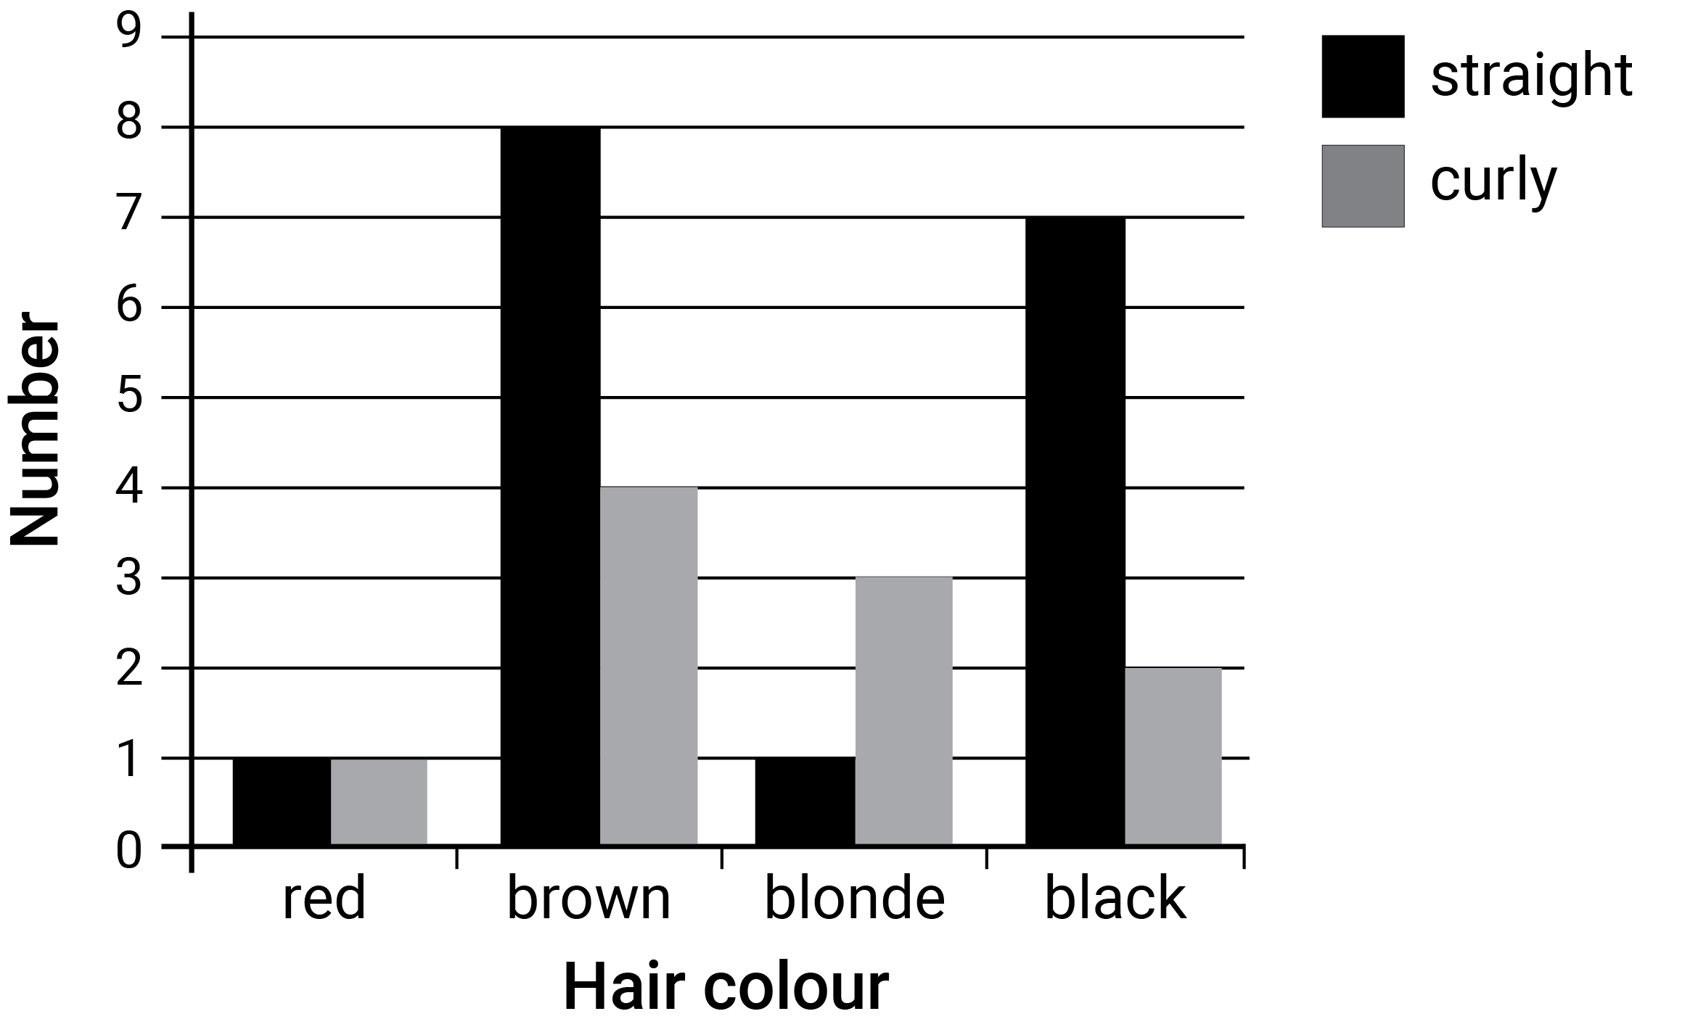
simulation
The process of simulating an event using technology or a device, e.g. if 2 players are equally likely to win a game on past performance, then games could be simulated by successive tossing of a fair coin.
simulations
A simulation is a recreation of a random phenomena used to collect probability data using either physical or virtual manipulatives such as spinners, coins and cards or computer generated simulations which can be performed a large number of times.
sine ratio  In any right-angled triangle, $\sin{θ=\frac{\text{opposite}}{\text{hypotenuse}}}$, where $0<θ<90$°. | 
skip counting
Counting from a given starting value using multiples of a fixed natural number, e.g. {2, 4, 6, ...} or {7, 12, 17...}.
spread
A statistic that indicates how widely the values of a data set are distributed. Common measures of spread include range, interquartile range, quantiles and percentiles.
square number
The result of multiplying a natural number by itself, e.g. $16=4×4=4^{2}$, and is an element of the set $\{0, 1, 4, 9, 16, 25 ...\}.$
square root
A value that when multiplied by itself gives the original number. The positive square root of a given real number $x$ is the positive real number $y$such that $y^{2}=x$.
statistical investigation
An investigation process involving a chosen context, area of interest or an identified problem scenario, identifying the subjects and variables to be investigated, planning the approach, collecting data, representing, interpreting and analysing the data, making inferences and communicating the results of the investigation in terms of the context.
stem-and-leaf plot  A method of organising and displaying numerical data in which each data value is split into 2 parts: a ‘stem’ and a ‘leaf’. Stem plots give a visual indication of spread. | 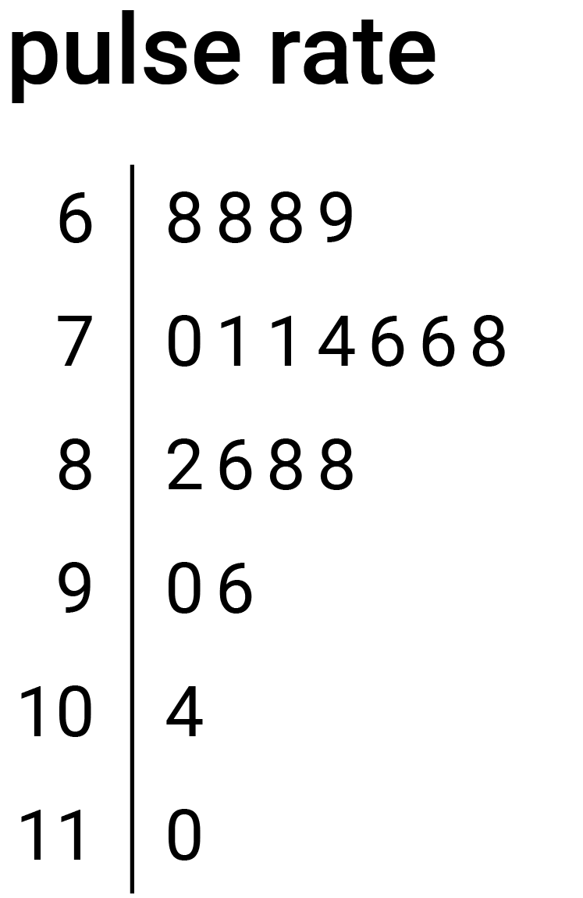
straight angle  The angle formed by 2 opposite rays on a straight line from a common point. A straight angle is also formed by a half turn of ray about its endpoint. It measures 180 degrees. | 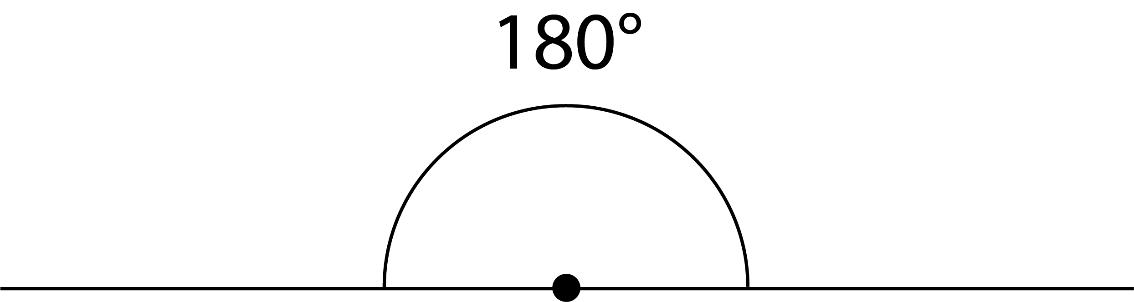
subitising
The capacity to visually recognise the size of a small set of objects without counting.
supplementary angles
Two adjacent angles that form a straight angle and their sum is 180 degrees (a straight angle).
surface area
The measure of the total area of the surface(s) of a 3-dimensional shape or object.
survey
A tool for collecting data that comprises a series of questions, which can be constructed to collect quantitative or qualitative data, numerical or categorical responses.
T
tangent ratio
The ratio of the length of the altitude, $a$, of a right-angled triangle to the length of its base, $b$, for a given base angle, theta, $θ$.
terminating decimal
A decimal expansion of a number which has a finite number of non-zero digits, e.g. 3.125.
tessellation  A repeated pattern in the plane or on a surface where shapes completely fill all of the space around a given point where their boundaries meet, e.g. a honeycomb is a tessellation using hexagons. | 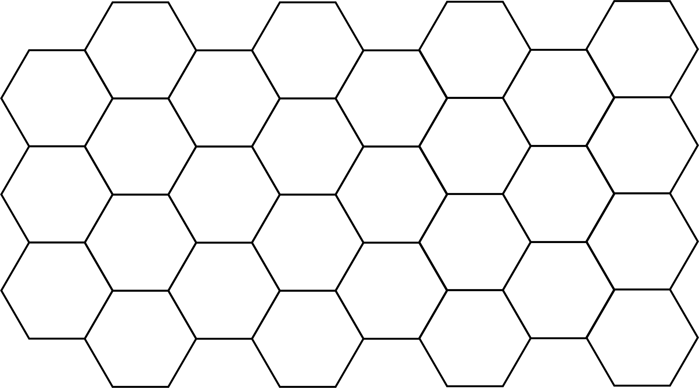
theorem
A statement which has been derived from given statements using agreed rules of deduction (proof).
three-dimensional
An object that has 3 independent dimensions of length, width (breadth) and depth, or a space in which position is specified by 3 independent coordinates.
three-dimensional coordinate system  A coordinate system where any point in the space is defined using 3 different dimensions, e.g. longitude, latitude and altitude for locating the position of a drone in the sky. | 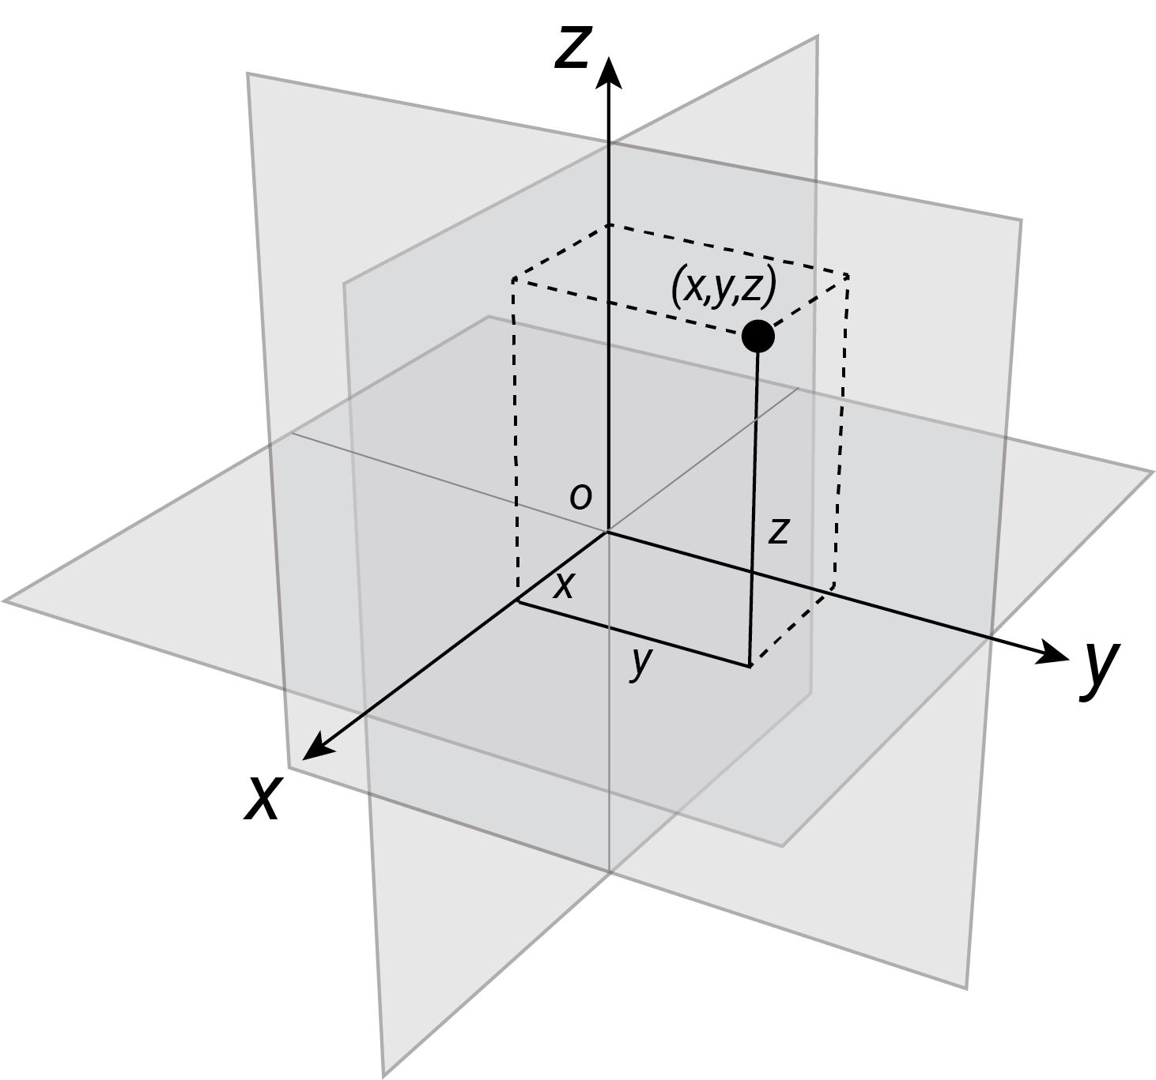
time zones
The 24 divisions of the globe, where each change of 15 degrees longitude corresponds to one hour. As time zones often align with national or regional boundaries this is an approximate relationship.
transformation
A map of the plane onto itself. Transformations include dilation (enlargements or compressions), reflections, rotations and translations.
translation
Shifting a figure in the plane without turning it. Translations can be specified as a combination of a horizontal shift and a vertical shift.
transversal
A line that intersects 2 other lines obliquely.
tree diagram  A diagram consisting of line segments (edges) connected to points (vertices) like the branches of a tree. It shows the relationship between sets, events, or the set of outcomes of a multi-step random experiment. | 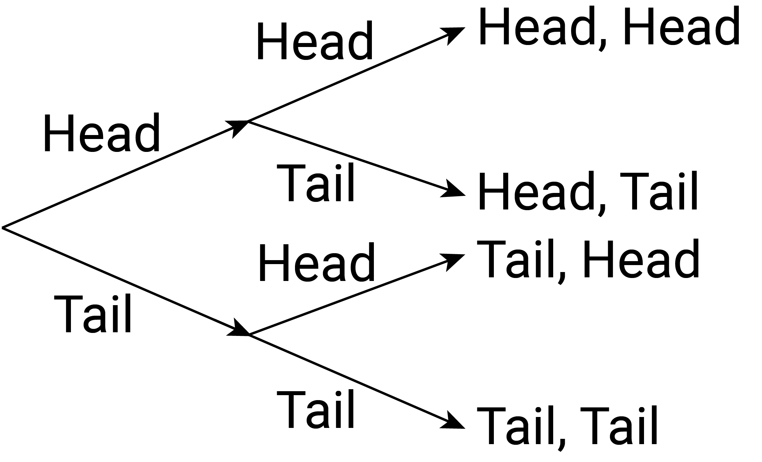
trials
Any repeatable procedures with a well-defined set of possible outcomes, known as the sample space, e.g. for the flipping of a coin the sample space would be {H, T}.
trigonometric ratios
Relationships between the angles and sides of right triangles. The 3 basic trigonometric ratios in this curriculum are: sine ($sin$), cosine ($cos$) and tangent ($tan$).
two-dimensional
A shape that has 2 independent dimensions of length and width (breadth) is 2 dimensional, as is a space in which position is specified by 2 independent coordinates, such as the plane.
two-way tables  A common way of displaying the two-way frequency distribution that arises when a group is categorised according to 2 criteria. | 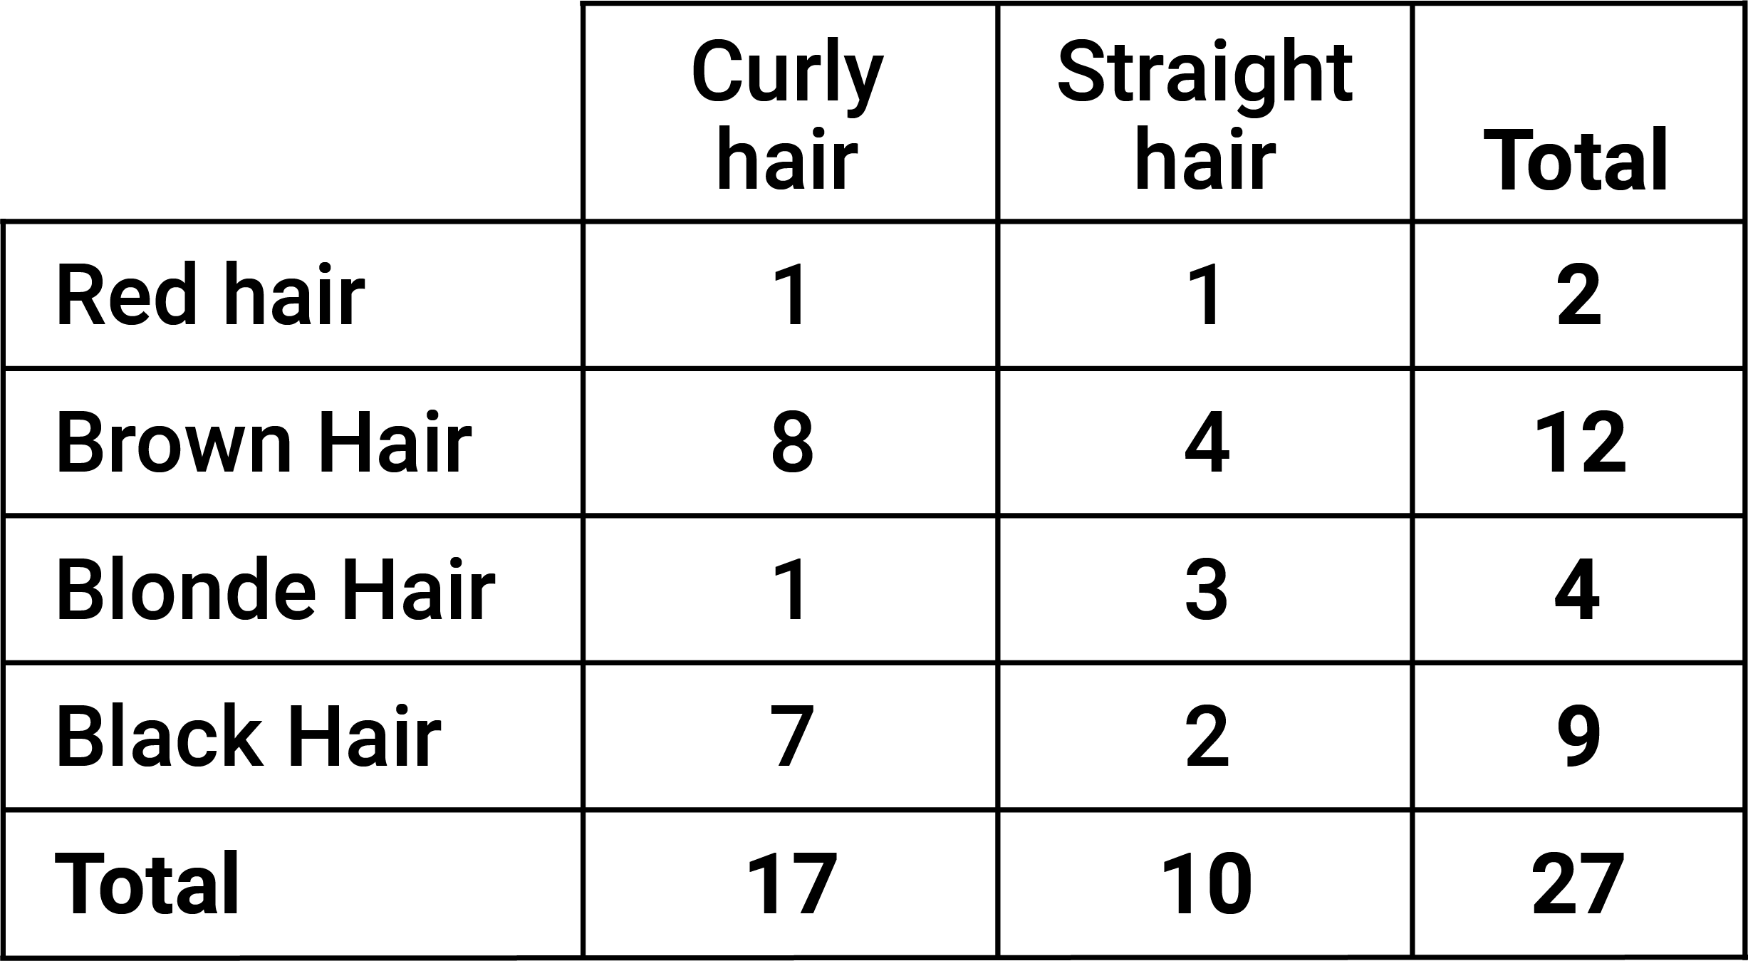
U
unit fraction
A fraction of the form $\frac{1}{n}$, where $n$ is a non-zero natural number, such as $\frac{1}{2}, \frac{1}{3} , \frac{1}{4}$...
unit of repeat
In a repeating pattern, the pattern sequence that is repeated within the pattern, e.g. 1234 in the pattern 1234123412341234...
units
The basis for counting or measurement or both, e.g. the number 1 is the unit for counting; the metre is the standard unit for measurement of length in the metric system.
univariate data
Data relating to measurement of a single variable, e.g. shoe size.
V
validate (data)
The process of checking that data to be analysed is reasonable and fit for purpose. This can involve checking for accuracy, clarity, detail, consistency, correctness and completeness.
variable
Things that are measurable or observable that are expected to either change over time or between individual observations. They are often designated by symbols, such as $n$, $x$ and $y$, to represent members of a set.
variation in data
The characteristic that elements of a data set differ, e.g. the maximum temperature recorded at different suburbs of a town on a given day.
Venn diagrams  Graphical representations, using several typically overlapping circles, showing elements of sets in relation to properties or attributes. They are drawn for some specified universal set. | 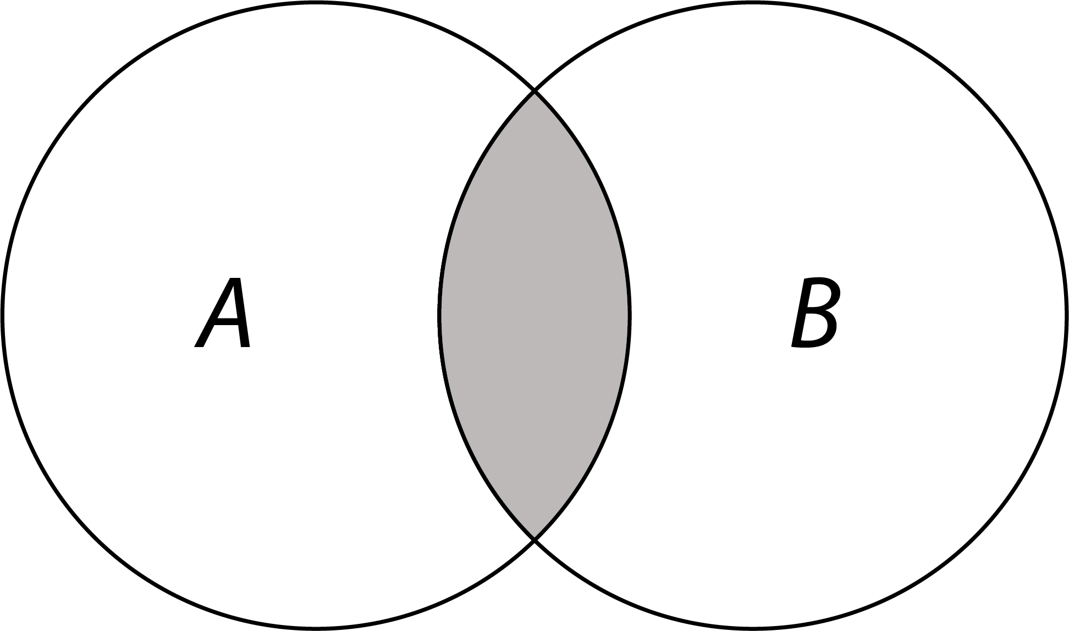
vertically opposite angles  Two pairs of vertically opposite angles formed at the point of intersection of 2 lines in the plane. Vertically opposite angles are equal. | 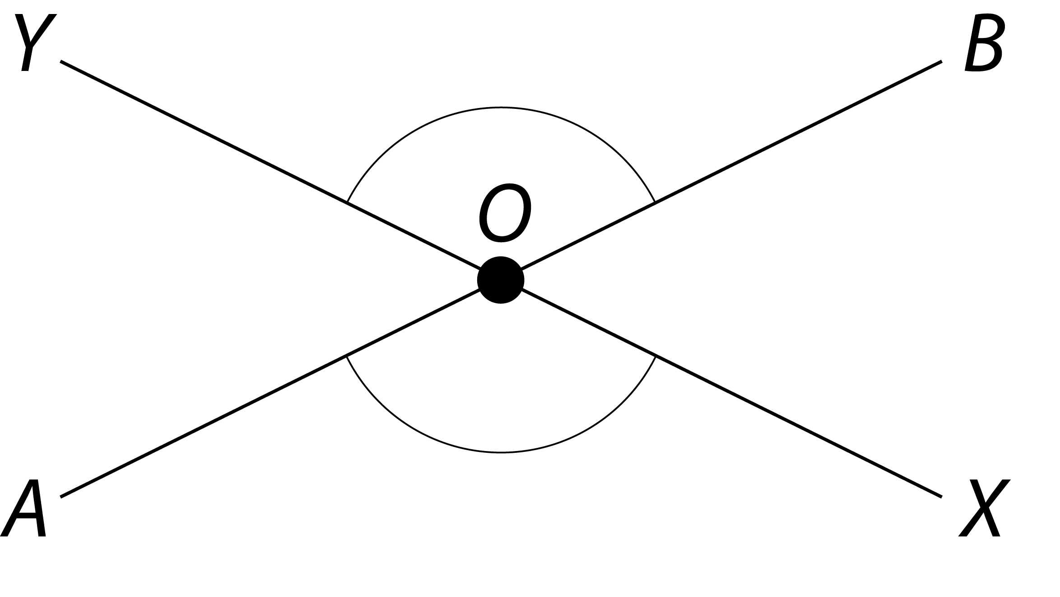
virtual materials
Dynamic digital representations of physical materials (sometimes called virtual manipulatives).
visualisations
Visual formats for organising, representing and summarising data. Also called data displays.
volume
The amount of space bounded by the surface of an object. It is usually measured in cubic units.
W
X
Y
Z
zero
The number represented by the numeral or the symbol 0, e.g. the origin on a number line. It also functions as an empty place-holder digit in the decimal expansion of numbers, e.g. 205.

